“EVALUATION OF CARDIAC CT PROFILE OF CONGENITAL HEART DISEASE
INTRODUCTION
A congenital heart disease (CHD), also known as a congenital heart anomaly/ congenital heart defect, is a defect in the structure of the heart or great vessels that is present at birth.Congenital heart diseases are known by a number of names including congenital heart anomaly, congenital heart disease, congenital heart defects, and congenital cardiovascular malformations.¹
The Signs and symptoms of the disease depend on the specific type of defect.² Symptoms can vary from none to life-threatening.³ Symptoms of CHD may include breathlessness, cyanosis, poor weight gain, and feeling tired.⁴
The reported prevalence of congenital heart disease (CHD) varies between 4- 10 per 1 000 live births¹⁻⁵. Advances in pediatric cardiac care have resulted in an increasing number of adults with CHD being followed up in a tertiary care centers.⁵⁻¹¹

The incidence of the Congenital Heart Disease in India is 6-8 per 1000 of live births¹.Survival of the patients with congenital heart disease has improved over a period of time due to early diagnosis by the various imaging modalities like 2D Echocardiography, CCT (Cardiac Computed Tomography), Cardiac Magnetic Resonance Imaging (CMRI) and coronary angiography (CA)¹². CT, including CT angiography (CTA), is important in the evaluation of congenital heart disease (CHD) and can be used for accurate depiction of complex cardiovascular anatomic features both before and after surgery for variety of post-treatment related complications. CT facilitates for the assessment of extra-cardiac systemic and pulmonary arterial as well as venous structures especially for major Aorto-pulmonary collateral arteries (MAPCAs). It is important for the radiologists to have extensive knowledge of anatomy of cardiovascular structures, physiology and surgical techniques.¹³

Although echocardiography and catheter-directed cardiac angiography are generally accepted as a primary imaging technique for evaluation of CHD, CT and MRI are important complementary diagnostic tools. In addition to being highly operator dependent, echocardiography may not be sufficient for evaluating the extra-cardiac structures, such as the pulmonary arteries, pulmonary veins, aortic arch,great vessels and major Aorto-pulmonary collateral arteries due to acoustic window limitations. Catheter-directed cardiac angiography is limited by its 2D nature and difficulties in simultaneous evaluation of the systemic and pulmonary vascular systems. As compared to CT scan, cardiac catheterization has a higher rate of complication due to its invasive nature, typically requires a larger volume of intravascular contrast material, more frequently requires general anesthesia, and often imparts greater radiation dose to the patient.¹⁴⁻¹⁷ CT can be used as problem-solving tools, especially in the evaluation of preoperative and postoperative cardiovascular anatomy and some postoperative complications.

Compared with older-generation CT, MDCT and newer scanners yield images with better temporal and spatial resolution, with greater anatomic coverage per rotation, more consistent enhancement in lesser volume of intravascular contrast material and higher-quality of 2D reformation and 3D reconstruction owing to acquisition of an isotropic data set.^{18,19} Rapid imaging with these CT scanners requires less patient sedation than older-generation CT, MRI, and conventional angiography.

Although the role of CT in the evaluation of CHD is being redefined and expanded, there are several generally accepted clinical indications for which the benefits of imaging greater than the risks. First, CT can be used to evaluate patients with known CHD or suspected on the basis of echocardiographic findings for which further imaging is needed to characterize extra-cardiac anomalies before intervention. The pulmonary arteries, pulmonary veins, aortic arch and great vessels may be inadequately characterized at echocardiography, that necessitating further assessment with CT. Second, CT can be used in the postoperative evaluation of CHD patients who have a variety of suspected treatment-related complications. Third, because CT facilitates rapid comprehensive assessment of thoracic cardiovascular structures, the lungs, and potential spaces, it can be used in the preoperative and postoperative evaluation of CHD patients whose condition suddenly deteriorates. In this situation, CT quickly displays variety of CHD-related complications and numerous other medical conditions, such as pulmonary embolism, pneumonia, pleural and pericardial effusion, and pneumothorax. Finally, CT can be useful before a re-operation to assess altered anatomic features that are related to previous surgery.²⁰

CT can be considered the first-line imaging technique for a few clinical indications. Examples are evaluation of suspected vascular ring or sling, suspected aortopulmonary collateral arteries in patients with severe right ventricular outflow tract obstruction and individuals with implanted pacemakers and metal surgical implant who cannot undergo MRI. The role of CT in the evaluation of intra-cardiac anomalies has been limited, although this situation is changing due to advances in MDCT scanners and ECG-gating techniques. In a small study in which they used a 40-MDCT scanner (without ECG gating), Lee et al. detected 53 of 54 intra-cardiac and extra-cardiac anomalies in neonates with complex congenital heart disease. No patient needed follow-up diagnostic angiography²¹.

A vital component to the multidisciplinary management of the congenital heart disease patient is adequate imaging of the heart and its circulation. However, simple anatomical delineation alone is not sufficient. CT Techniques are required which can measure function, flow and pressure as well as resolve anatomical structures with a high degree of detail.

Echocardiography and catheter cardio-angiography are the primary cardiac imaging modalities, but both have weaknesses. Echocardiography is limited by a small field of view, an acoustic window, and it is operator dependence. Catheter cardio-angiography is limited by the overlapping of adjacent vascular structures, difficulty in demonstrating systemic and pulmonary vascular systems simultaneously, catheter-related complications (especially in young children), and relatively high doses of ionizing radiation and iodinated contrast material. Cardiac Computed tomography (CT) imaging has important roles in overcoming these limitations.

CT has been used in the morphologic evaluation of congenital heart disease (CHD). Multislice spiral CT is used because of its fast image acquisition time and capacity to obtain volume data. Cardiac imaging with CT depends on technical developments because high temporal and spatial resolution is necessary for the satisfactory evaluation of CHD. In addition, multiplanar evaluation is essential because each vascular structure has its own axis—an axis that is different from the axis of the adjacent vascular structures. Recently introduced multislice spiral CT comes close to fulfilling all these requirements.²²⁻²⁶

The preoperative understanding of congenital heart disease provided by CT make surgical decision easy and consequently may improve outcome. Rapid imaging with these CT scanners requires less patient sedation than older-generation CT. CT can be used in the postoperative evaluation of complications in CHD patients who have a variety of suspected treatment-related complications. In CHD patients whose condition suddenly deteriorates; CT quickly displays evidence of a variety of CHD-related complications.¹⁹⁻²⁰

Interpretation of imaging information of congenital heart disease requires detailed knowledge of embryology, anatomy and understanding the strength and limitations of imaging techniques. Understanding of concepts of imaging and how to apply best for a clinical situation is an essential component of imaging in congenital cardiac disease.

The radiologist should tailor radiation delivery to obtain the minimum image quality sufficient to provide the required diagnostic information. If appropriate protocols and strategies for dose reduction are applied, CT could become a low-radiation technique. Because of its simplicity and high performance, cardiac CT scanning will improve its role in congenital cardiac imaging.

Hence the present study was done at our tertiary care center to study the various Congenital Heart Diseases using Cardiac Computed Tomography (CT) and assess the morphological details of congenital heart diseases.

AIMS AND OBJECTIVES

AIM:
- To study various Congenital Heart Diseases using Cardiac Computed Tomography (CT)

OBJECTIVES:
- To study various types of simple & complex congenital cardiovascular anomalies with CT findings.
- To study associated extra-cardiac anomalies with CT findings.
- To study the morphological details of congenital heart diseases before surgery with CT findings.
- Toevaluate various post-operativecomplicationsincongenital heart disease.

NORMAL CARDIAC ANATOMY ON CARDIAC CT

Awareness of the normal cardiovascular anatomy is a prerequisite for understanding CHD. The basic anatomy in CHD with respect to the aorta, pulmonary artery, pulmonary vein, cardiac chambers, coronary artery, and valves and the normal bronchial branching pattern is necessary for evaluation of the situs anomaly.

Aorta:
The aorta consists of an ascending segment, arch, and a descending segment. The ascending aorta arises from the left ventricle and its proximal portion is called the aortic root and includes the aortic valve, annulus, and sinuses of Valsalva. The ascending aorta extends to the origin of the Brachiocephalic trunk . The aortic arch begins at the brachiocephalic trunk and ends at the ligamentum or ductus arteriosum. It gives rise to the brachiocephalic trunk, left carotid, and left subclavian arteries. The distal part of the aortic arch after the origin of the left subclavian artery is called as aortic isthmus. The aortic arch is normally on the left side. The descending aorta begins at the ligamentum or ductus arteriosum, and its proximal portion may look slightly dilated. The intercostal and bronchial arteries are the branches of the descending aorta.
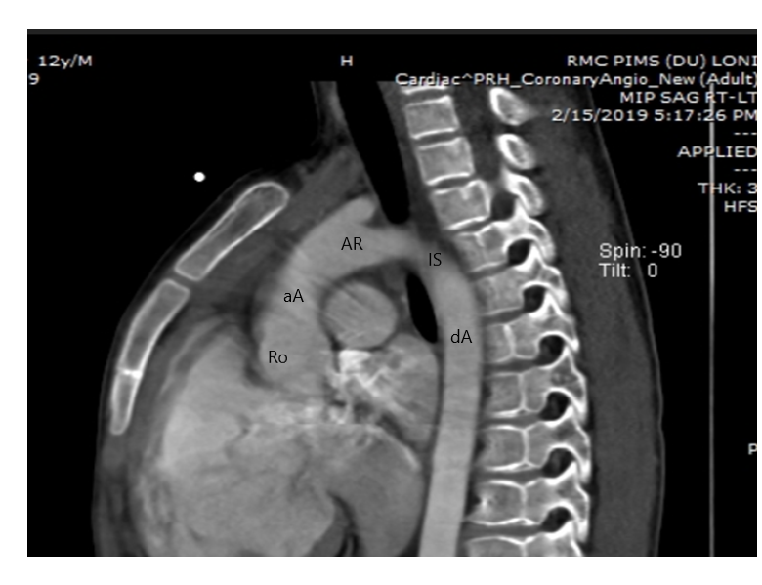
here
Fig no 1 : Normal aorta. CT scan shows the ascending aorta (aA), aortic arch (Ar), and descending aorta (dA). The aortic root (Ro) represents the proximal portion of the ascending aorta and the aortic isthmus (Is) represents the distal portion of the aortic arch.

Pulmonary Artery:
The main pulmonary artery arises from the right ventricular outflow tract and it passes to the left and posterior to the aorta and divides into the right and left pulmonary arteries. The left pulmonary artery is shorter and higher than the right pulmonary artery and it courses in a more posterior direction. The right pulmonary artery passes behind the ascending aorta, superior vena cava (SVC) and right upper pulmonary vein. Right and left pulmonary arteries divide into ascending and descending branches. Branches of the pulmonary artery to both lungs usually follow the corresponding bronchial course; however,variations may occur in the upper lobes.

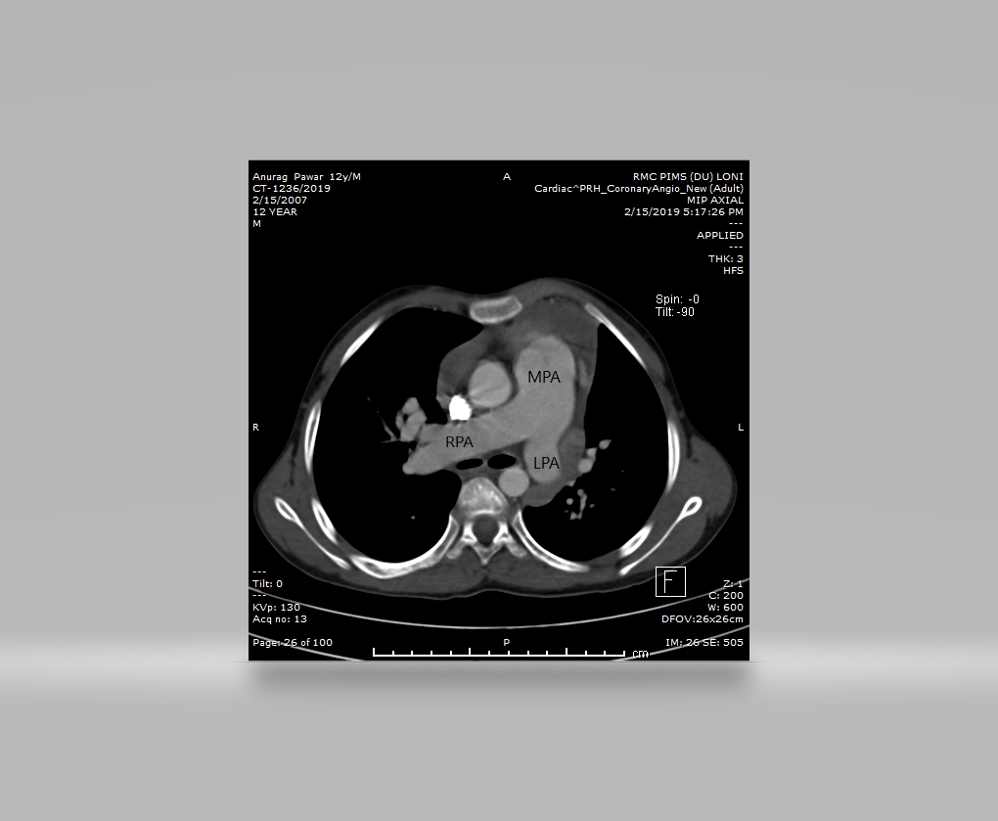

Fig no 2: Normal pulmonary arteries.

Pulmonary Vein:
The pulmonary veinsnormally drain into the left atrium. On right side middle and upper lobe veins join to form the right superior pulmonary vein. The left superior pulmonary vein receives blood from left upper lobe. The right and left inferior pulmonary veins receive blood from the right and left lower lobes respectively.
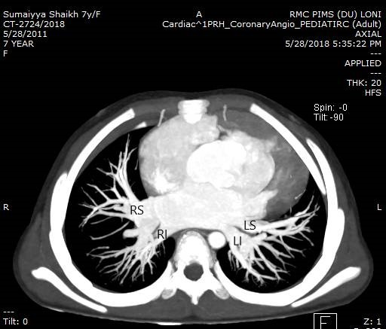

Fig no 3 : Normal pulmonary veins. CT scan shows all the pulmonary veins, including the right superior (RS), right inferior (RI), left superior (LS), and left inferior (LI) pulmonary veins, with a normal venoatrial connection with the left atrium.

Cardiac Chambers:
In the right cardiac chambers, there is a muscular structure (ventriculo-infundibular fold) between the tricuspid and pulmonary valves, manifests as discontinuity between the valves. In contrast, the left cardiac chambers show fibrous continuity between the mitral and aortic valves. Right ventricle is characterized by the coarse trabeculae and moderator band (an extension of the anterior limb of the trabecula septomarginalis to the apical free wall). However, the left ventricle shows fine trabeculae and a smooth endocardial surface. Normally the tricuspid valve is slightly more apical in location than the mitral valve. The right atrial appendage is characterized by its triangular shape with wide opening and the pectinate muscle, whereas the left atrial appendage is fingerlike with narrow opening and shows no pectinate muscle. The right atrium is divided into the right atrium proper and the right atrial appendage by the crista terminalis also known as sulcus terminalis. The inferior vena cava (IVC) and the coronary sinus have valves at the right atrium and are known as the eustachian and thebesian valves, respectively.
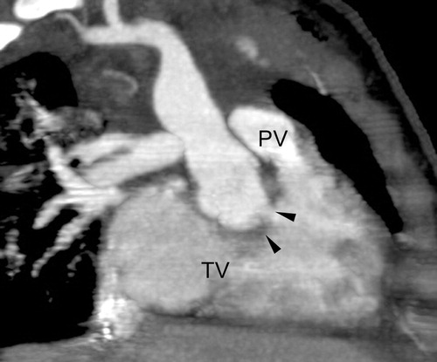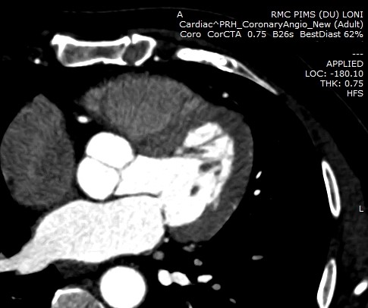
AV
MV
( a ) ( b )
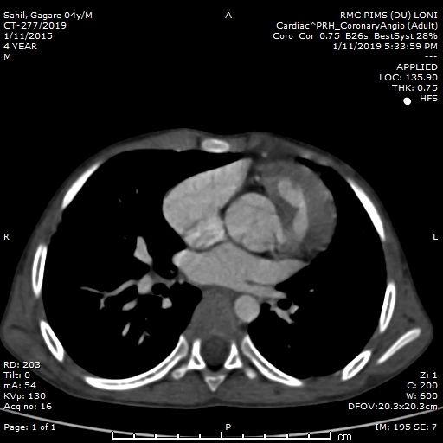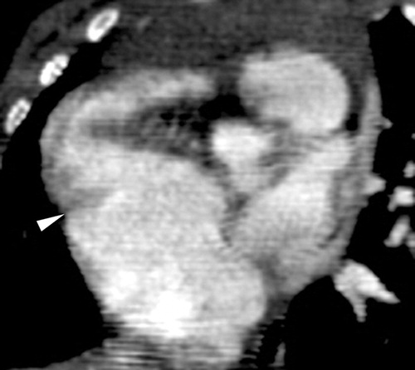
LAA
RAA

( c ) ( d )
Fig no 4 : Normal cardiac chambers. (a) CT scan of the right cardiac chambers demonstrates a muscular structure (arrowheads) between the tricuspid valve (TV) and the pulmonary valve (PV). The right ventricle shows coarse trabeculae. (b) CT scan of the left cardiac chambers demonstrates mitral valve (MV) and the aortic valve (AV). The left ventricle shows fine trabeculae. (c) CT scan shows the atrial appendages with a characteristic appearance. The right atrial appendage (RAA) is triangular in shape with a wide opening, whereas the left atrial appendage (LAA) isfingerlike in shapeand has narrow opening. (d) CT scan shows the crista (sulcus) terminalis (arrowhead), an anatomic landmark between the right atrium proper and the right atrial appendage.

Bronchial Branching Pattern:
The left lateral wall of lower trachea is mildly indented by the left aortic arch. The right main bronchus is short and vertical, whereas left main bronchus is long and horizontal. The relationship between theupper lobe bronchus and the branch pulmonary artery ischaracteristic. The right pulmonary artery courses anterior and lateral to the right main bronchus. The right upper lobe bronchus is superior to the descending branch of the right main pulmonary artery (eparterial bronchus) whereas left pulmonary artery courses over the left upper lobe bronchus (hyparterial bronchus).
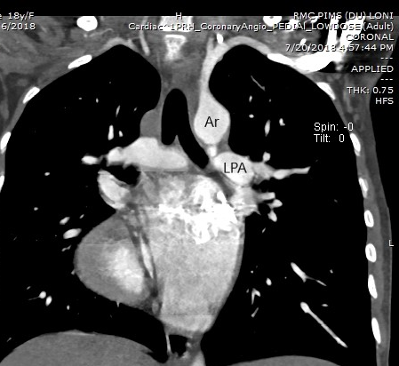

Fig no 5: Normal bronchial branching pattern. Coronal image depicts a normal bronchial branching pattern. Note the mild indentation of the trachea by the left aortic arch (Ar).

Coronary Artery:
Each coronary artery is arising from the corresponding aortic sinus. The left coronary artery is further divided into the left anterior descending artery and the left circumflex artery. The left anterior descending artery courses along the anterior interventricular groove, whereas the left circumflex artery courses along the left atrioventricular groove. The right coronary artery courses along the anterior atrioventricular groove.
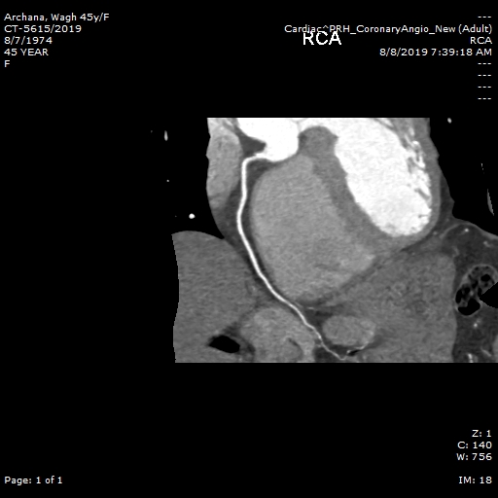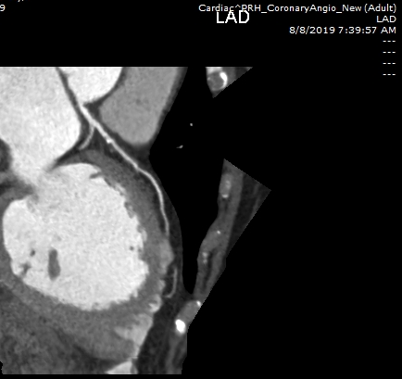
RCA
LCX
LAD
LCA
- (b)

Fig no 6: Normal coronary arteries. (a) On a CT scan, the right coronary artery (RCA) ,(b) left coronary artery (LCA). CT scan shows how the left coronary artery (LCA) is divided into the left anterior descending artery (LAD) and the left circumflex artery (LCX).

Valves:
The main pulmonary artery is normally anterior and to the left of the ascending aorta. The aortic valve is deeply wedged between the tricuspid and mitral valves and consists of the right, left, and noncoronary cusps.Noncoronary cusps being posterior in location, whereas the pulmonary valve consists of the right, left, and anterior cusps. The tricuspid valve consists of septal, anterior, and posterior leaflets, whereas the mitral valve consists of the aortic (anterior) and mural (posterior) leaflets.
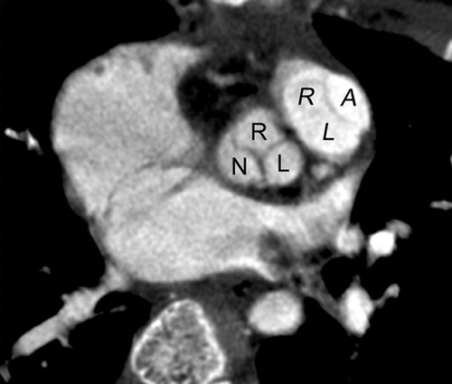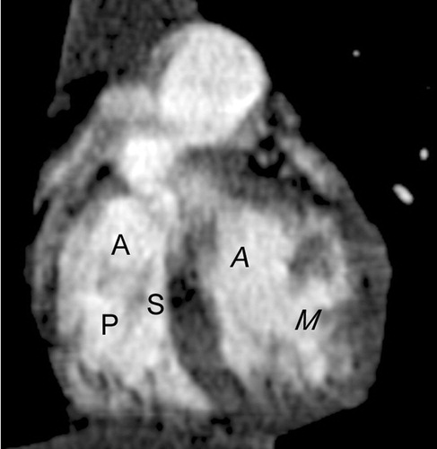

Fig no 6: Normal valves. (a) CT scan shows the aortic valve with right (R), left (L), and noncoronary (N) cusps and the pulmonary valve with right (R), left (L), and anterior (A) cusps. (b) CT scan shows the tricuspid valve with septal (S), anterior (A), and posterior (P) leaflets and the mitral valve with aortic (A) and mural (M) leaflets.

Mechanism: Congenital heart defect
There is a complex sequence of events that result in a well-formed heart at birth and disruption of any portion may ultimately result in a defect. The orderly timing of the cell growth, cell migration, and programmed cell death ("apoptosis") has been studied extensively and the genes that control the process are being elucidated. Around 15thday of development, the cells that will become the heart exist in two horseshoe shaped bands of the middle tissue layer (mesoderm),²⁷ and some cells migrate from a portion of the outer layer (ectoderm), the neural crest, which is the source of a variety of cells found throughout the body. On 19thday of development, a pair of vascular elements, the "endocardial tubes", form. The tubes fuse when cells between them undergo programmed death and cells from the first heart field migrate to the tubeand form a ring of heart cells (myocytes) around it by day. On day 22, the heart begins to beat and by 24thday, blood is circulating.²⁸

On day 22, the circulatory system is bilaterally symmetrical with paired vessels on each side and the heart consisting of a simple tube located in the midline of the body layout. The portion that will become the atria, it will be located closest to the head are the most distant from the head. From 23rdup to 28th day, the heart tube folds and twists, with the future ventricles moving left of center (the ultimate location of the heart) and the atria moving towards the head.²⁸

On day 28, areas of tissue in the heart tube begin to expand inwards; after about two weeks of these expansions, the membranous "septum primum" and the muscular "endocardial cushions", are fuse to form the four chambers of the heart and failure to fuse properly will result in a defect that may allow blood to leak between chambers. After this happens, cells which have migrated from the neural crest begins to divide into the bulbus cordis, the main outflow tract is divided in two by the growth a spiraling septum, becoming the great vessels—the ascending segment of the aorta and the pulmonary trunk. If the separation is incomplete, that results in a "persistent truncus arteriosus". The vessels may be reversed i.e. "transposition of the great vessels". The two half of the split tract must migrate into the correct positions over the appropriate ventricles and failure may result in some blood flowing into the wrong vessel e.g. Overriding aorta. The lungs are unexpanded and cannotaccommodate the full circulatory volume. Two structures exist to shunt blood flow away from the lungs. Cells in a part of the septum primum die creating a hole while muscle cells, the "septum secundum", and grow along the right atrial side the septum primum, except for one region, leaving a gap through which blood can pass from the right artium to the left atrium, the foramen ovale. A small vessel, the ductus arteriosus allows blood to flow from the pulmonary artery to pass to the aorta.²⁸

Changes at birth
The ductus arteriosus stays open because of the circulating factors including prostaglandins. The foramen ovale stays open because of the flow of blood from the right atriumto left atrium. As the lungs expand, blood flows easily through the lungs and the membranous portion of the foramen ovale i.e. the septum primum flops over the muscular portion i.e. the septum secundum. If the closure is incomplete, it will results in a patent foramen ovale. The two flaps may fuse, but many adults have a foramen ovale , that stays closed only because of the pressure difference between the atria.²⁸

Theories
Rokitansky (1875) explained congenital heart defects, as breaks in heart development at various ontogenesis stages.²⁹ Spitzer (1923) treats them as returns to one of the phylogenesis stages.³⁰ Krimsky (1963), synthesizing two previous points of view, considered congenital heart diseases as a stop of development at the certain stage of ontogenesis, corresponding to this or that stage of the phylogenesis.³¹ Hence these theories can explain the feminine and neutral types of defects only.

REVIEW OF LITERATURE

Computed tomography was developed in the 1972 and was later made commercially available for clinical use in 1974. Tomography is a Greek word, “tomos” meaning “slice” or “section” and “graphia” meaning “describing”. Medical CT was first developed by British engineer Godfrey Hounsfield of Electric and Musical Industries (EMI), and American physicist Allan Cormack of Tufts University, Massachusetts (Calhoun et al, 1999). In 1979, Hounsfield and Cormack received Nobel Prize for their contribution to science and medicine.

Cardiac CT has passed through three, chronologically overlapping, developmental stages and now it is, in its fourth stage of development. The first stage was fluoroscopy-based CT (1972–1995) stimulated by physiologic research needs. The next was clinical CT-based exploration (1975–1980) of the potential of clinical CT in cardiology which is followed by the electron beam CT-based stage (1980–present), which was the first CT approach applicable to clinical cardiology. Finally, volume-scanning CT imaging methods achieved with multislice scanning approaches of helical CT and by flat panel-based CT (1990–present) which show great promise for clinically applicable CT of the cardiovascular system.

First phase of cardiac CT (1972–1995):
Cine angiography in the 1950s was followed by video fluoroscopic angiography in the 1960s, but, because of the ‘‘stop-action’’ replay of television was not available until the late 1960s so, cine angiography was still used to estimate left ventricular volume, ejection fraction, left ventricular (LV) myocardial mass , myocardialcontractility and stiffness, valvular competence, and abnormal anatomy of the cardiac chambers and major vessels³². Once ‘‘stop action’’ video replay, became possible, cine angiography was progressively replacedby video angiography. Being electronic, the video fluoroscopic approaches could be extended to provide tomography-based 3-D imaging. Later in the early 1970s, two independent efforts were undertaken in the laboratories of N.A. Baily³³ and of E.H. Wood. The more extensive and sustained effort in Earl Wood’s laboratory emerged with two initiatives. One was the video densitometry³⁴, which was developed in an effort to evaluate valvular incompetence and blood flow in vessels, basically it was an image-based extension of the catheter-sampled indicator dilution techniques developed in the Dr. Wood’s laboratory in the 1950s³⁵. Video densitometry had two problems, one was that there was superposition of surrounding tissues on the vesselor myocardium of interest. Quantitation of the indicator dilution curve in the region of interest required to have that superimposedbackground subtracted. Although this was well achieved by interpolation of the background on either side of the region of interest, it was seen that subtraction of the images which was recorded before and after injection of contrast was preferable. Although, electronic image subtraction was attempted by B.G. Ziedes des Plantes³⁶ and by R.E. Sturm in the late 1960s³⁷, but the time-base instabilities of electronic image technology made this impractical at that time. The stable image subtraction was achieved once high-fidelity video image analog-to-digital conversion became available. This was most easily achieved, if the video image was converted to digital form. This led H.C. Smith et al³⁸, in 1973, to do what must be one of the, if not the, first examples of what became known as ‘digital subtraction angiography’. But having achieved this, the intravascular contrast medium in the anterior and posterior walls of the myocardium was still superimposed, a problem that would best be solved with 3-D imaging. In addition to providing a stimulus for the development of 3-D imaging, the use of a video densitometric method to estimate left ventricular chamber volume by B.G. Trenholm et al³⁹ also contributed directly which showing the way toward achieving 3-D imaging by way of CT.Concurrently with the development of video densitometry, the video fluoroscopic methodology, videometry, was also developed and they are used to implement the ‘‘Chapman’’ method⁴⁰ of computed left ventricular chamber volumes.

In the 1950s and 1960s the angiographic methods ofestimating left ventricular chamber volumes were based on the assumption that the shape of the chamber was spheroidal or ellipsoidal, so that monoplane or biplane images could provide the major and minor axes of that ellipsoid. These methods were unsatisfactory because the chambers were notellipsoidal and had papillary muscles that further complicated its shape. The development of electronic imaging, combined with the ability to measure the angiographic dimensions electronically enabled Dr. Wood’s laboratory to routinely apply the ‘‘Chapman’’ method, which assumes that the LV chamber consists of a stack number of angiograms and test phantom images. The videometry system eliminated the logistic logjam that previously inhibited its use because of the slow and manual measurement of the multiple transverse diameters of the opacified LV chamber. Consequently, this method soon further showed that, while accuracy of the estimated volume did increase somewhat, it was never going to be very accurate. This was because the major and minor axes of the cross-sections, generally cannot be derived from their biplane projections. Moreover, 3-D displays that generated from these angiographically-derived dimensions clearly showed that the 3-D shape of the LV chamber was not accurately captured. This soon led to the realization that many angles of view were needed to overcome this problem and that projections of the outlines of cross-sections would never provide a measurement of the degree of concavity in the cross-section. However, the concurrent developments in video-densitometry, which showed that, the information about concavities in the opacified LV chamber could be obtained from the video-density information, led in 1972 to a solution for computing an image of the true cross-section. And this solution consisted of imaging at multiple angles of view and using the roentgen density information in those images rather than the dimensions of the angiographic silhouette outlines.

With the input of G.T. Herman of SUNY Buffalo, the first tomographic image of a heart was generated with a video-fluoroscopic system⁴¹. At the same time, the news about the newly developed EMI head CT scanner, and somewhat later, about the single slice whole-body CT scanner by R.S. Ledley et al⁴² became public. The video-fluoroscopic approach was rapidly advanced into a volume scanning tomography device with which the first dynamic 3-D images of the entire beating heart were generated at 33 ms intervals throughout a single heart cycle. Having developed this single-source tomographic reconstructing imaging system, a design for a stop-action, high-repetition rate and volume scanning CT system (the Dynamic Spatial Reconstructor [DSR]) was proposed. This design evolved over several years and in1974, repeated attempts were made to secure NIH funding to build this scanner. Later, the final design that was funded by NIH in 1976 consisted of 28 X-ray sources arranged around a semicircle and an opposing fluorescent screen which converted the X-ray images to light images which were then captured by 28 TV cameras focused onto those 28 different angles of view. The performance characteristics of the DSR were as follows: a cylindrical volume, 10.5 to 21 cm in a axial height (depending on the slice thickness chosen, 0.7 or 1.4 mm) and between 21 and 40 cm in a trans axial diameter (depending on the duration of the scan chosen) was scanned over 11 ms and rescanned every 16.7 ms for up to 1200 sequential scans over a 20-second period. The 3-D image consisted of cubic voxels and the scan aperture time could be extended by using time-sequential scan data. For many purposes, a scan aperture duration of 125 ms (which is acceptable during the diastolic slow filling phase, and could be retrospectively timed with 16.7 ms precision) was used, because this setting increased the number of angles of view available for the tomographic image reconstruction, which resulting in better image quality.

The system was built (but with sufficient funds only for 14 X-ray sources and the corresponding TV cameras) and installed in late 1979, and its imaging characteristics were established not too long afterwards. In the late 1970s several other multi–X-ray source designs were proposed, but none of these scanners was ever built for human use. The DSR system was used over the next 15 years for animal experiments and in patients for numerous research protocols. The video images were recorded to analog video discs that were then replayed one frame at a time in stop-action for analog-to-digital conversion and for reconstruction.

The filtered backprojection reconstruction assumed a stack of fan beams rather than more accurately accounting for the so-called, cone beam geometry. A practical solution for a more correct cone beam CT reconstruction algorithm did not become available until Feld-kamp’s publication in 1984⁴³. The DSR was subsequently improved with use of charge-coupled device (CCD) cameras and on-board analog to- digital conversion as well as chip-based digital memory. In addition, the use of angle dependent X-ray exposure and angle-dependent side-to-side X-ray shutters were introduced to reduce X-ray exposure and to reduce ‘‘cross talk’’ between contiguous X-ray source/fluorescent screen units of the scanner. The DSR project achieved its initial researchgoals and it served as a stimulus for the early developmentof many 3-D-image display and analysistechniques. Technical issues, such as the roles of CT imaging variables, including tomographic image slice thickness and the maximum acceptable duration of the scan aperture during the various phases of the cardiac cycle, were defined. The DSR was dismantled in year 1998, almost 20 years after being installed and its impact on the field of cardiac CT is open to some question. Perhaps this is because, it was a one-of-a-kind scanner, and certainly the scanner was not turn-key operational. Therefore, others could not conveniently, independently verify or modify methodologies, let alone use them to do other types of studies. The lack of enthusiasm for duplicating the scanner was probably because of several factors and nonetheless, many of the current approaches to three-dimensional image display and the associated terminology for 3-D imaging (such as ‘‘voxel’’) emanated from the DSR project.

Second phase cardiac CT (1975–1980):
Soon after the EMI head scanner was introduced clinically in 1972, many other companies built their own versions of scanners⁴⁴ and progressed to whole-body scanners that were then used to look at the heart. The fastest clinical CT scanners required at least one second to complete a scan of a single slice, which was generally inadequate for imaging the heart, even with ECG gating. Consequently, these scanners could only be used to examine the potential for CT in imaging of cardiac shape, myocardial material properties and perfusion distribution. Even in those instances where, with heroic experimental manipulation of the anesthetized animal so that a satisfactory scan of a single slice could be generated, three major problems were remained. First, contrast agent had to be infused over at least the duration of the scan sequence, so that changes in contrast concentration in blood and in extravascular space occurred during the scan, which created problems because of image artifacts. Second, even if the single slice was scanned fast enough for effective stop-action imaging, contiguous slices of the heart, imaged by advancing the table a small distance after each scan was completed, could be at different phases of the cardiac cycle, leading to a radar kymography-like⁴⁵ effect that resulted in an incorrect composite 3-D shape of the heart generated from the sequentially scanned cross-sections. Third, repeated ‘‘stop-action’’ imaging during passage of a transient bolus of contrast agent could not be readily performed, so that accurate indicator dilution curves could not be acquired. Most importantly, these studies clearly showed that existing clinical CT scanners were not suitable for routine cardiac imaging in a clinical setting and it was felt that cardiac CT had a bright future for certain applications.

Third phase cardiac CT (1980–present):
The first successful and clinically applicable cardiac CT scanner was the Imatron C100 ‘‘Ultrafast’’ or‘‘Cine’’ CT scanner⁴⁶. Its main innovation was that it used no moving parts. The X-ray source consisted of a moving X-ray focal spot and generated on a semicircular anode under the supine patient, and of two semicircular, closely adjacent, detector arrays that were suspended above the patient. The focal spot was generated by a focused electron beam and that was electromagnetically swept, over a period of 50 ms, sequentially along each of four adjacent anodes. Consequently, the scan information for eight near-contiguous slices was generated over approximately 250 ms. But however, with a slice thickness of 7 mm and the average center-to-center distance of the slices being 10 mm, the axial quality of the image data was rather crude. The dual-slice scan sequence could be repeated at a rate of 17 per second, the so-called ‘‘cine-mode.’’ Although the scanner was subsequently improved somewhat technologically (Imatron C150) and also in its mode of operation, which improved image quality and reduced slice thickness, the system was fundamentally limited by its scanning geometry in which the detector array and focal spot trajectory along the anode were not coplanar. Therefore, the cone beam effects could not be readily compensated for in the fast scanning mode. The initial application of the scanner was primarily in a research demonstration mode. Nonetheless, the scanner was not a widespread clinical success except in special applications requiring speed, such as pediatric cardiology⁴⁷, emergency room evaluations, and the diagnosis of pulmonary embolism.

The new generation scanner was modified so that the patient was transported along the cephalo–caudal axis during the cardiac scan, thereby generating images of contiguous or slightly overlapped thin slices over the full extent of the heart during one or two breath hold episodes.

Fourth phase of cardiac CT (1990–present):
In the early year 1990s, the concept of helical (or, geometrically less accurately, ‘‘spiral’’) CT scanning was developed⁴⁸.It involves translating the patient continuously through the transaxial scan plane during the scanning procedure. In this manner, data are recorded such that a stack of contiguous or overlapping slices can be computed over the entire extent of the axial translation. Even with slow scanning speed, coronary arteries could be imaged⁴⁹. It wasn’t until the mid-1990s, however, that cardiac imaging was made possible by the high-spatial resolution, multi-slice imaging capability, faster continuous rotation of the X-ray source, its opposing detector array, and retrospectively gated binning of the scan data. In recent years, scanner speed has increased remarkably so that an aperture time of less than 200 ms is now available and so, an entire heart can be scanned in less than one breath hold period. As a consequence,3-D imaging of the opacified coronary artery lumen, coronary calcification and the coronary arterial wall is now becoming possible.

Coronary computed tomography (CT) is well established for the assessment of symptomatic patients with suspected but not yet confirmed coronary artery disease with high diagnostic accuracy and risk prediction. With the advent of fractional flow reserve computed tomography ( FFR_{CT}), enabling anatomy and physiology with a single study and the ability to adjudicate lesion specific pressure loss, the potential of combined coronary CT angiography (CCTA) and fractional flow reserve (FFR) computed from non-invasive CT angiography (FFR_{CT}) to inform treatment decision-making and help guide revascularization has been recognized.

Most recently an electron beam-based scanner (using Imatron’s concept) is being developed, and is advertised to reduce the scan time to 33 ms and to complete a 100 mm axial scan in 1 second. And this looks promising for achieving the goal of scanning the entire 3-D extent of the heart within one cardiac cycle. Another new approach to cardiac CT involves, the use of conventional, but modified, image intensifier-based C-arm fluoroscopy systems⁵⁰. Flat panel array detectors enhance this approach because of the reduced bulk of the imaging device, lack of sensitivity to the earth’s magnetic field and the greater efficiency of X-ray-to-signal conversion. In addition to this, flat panels can also be used as detector arrays in more conventional CT scanners. There are several types of physics principles underlying these arrays, but basically, they all consist of a roentgenogram-sized flat panel and made up of small detector elements (dexels) less than 100 micrometer on a side and these dexels convert the X-ray exposure into a proportional electrical output with high conversion efficiency. The advanced multi-detector CT (MDCT) technology with its improved spatial and temporal resolution has made it an effective tool in the assessment of CHD. The value of MDCT in the evaluation of the thoracic vascular anomalies has been widely confirmed. As this imaging modality can not only provide information about cardiovascular structure, but also offer additional information about the airway and lung parenchyma and so resulting in a greater anatomic coverage.

A recently introduced dual-source CT (DSCT) system provides the high-pitch scan technique and in this high-pitch mode, data acquisition is prospectively triggered with the ECG. With a very high pitch of 3.4, and a table speed of 460 mm/s, the entire heart can be covered within one single cardiac cycle. Due to the fast, non-overlapping spiral data acquisition, the radiation dose was consequently reduced.

The prospective ECG-gated sequential technique has been proven one of the most effective method to lower the radiation dose. The sequential mode allows high diagnostic accuracy in the assessment of intracardiac, extracardiac and coronary anatomy in patients with CHD and the image quality is seldom influenced by the variability of the heart rates.

Congenital Heart Disease: Typical Pathologic Conditions
Extracardiac Abnormalities
Interrupted Aortic Arch:
Interrupted aortic arch (IAA) is defined as a separation between the ascending and descending aortas^{22-23,48-50} .It is classified on the basis of the site of interruption: Type A is distal to the subclavian artery, type B is occurs between the second carotid and the ipsilateral subclavian arteries, and type C is occurs between two carotid arteries. Each of these three types are further subdivided as follows: Subtype 1, normal subclavian artery; subtype 2, aberrant subclavian artery; and subtype 3, an isolated subclavian artery that arises from the ductus arteriosus. The evaluation of the distance between the proximal and distal segments, the size of a patent ductus arteriosus (PDA), the narrowest dimension of the left ventricular outflow tract, and other cardiac structural abnormalities are important for surgical planning.

Coarctation of the Aorta:
In classic coarctation of the aorta, the narrowing is located just distal to the left subclavian artery. Coarctation of the aorta at or immediately proximal to the left subclavian artery is rare and compromises that vessel. An aberrant right subclavian artery may arise at or below the coarctation segment. The segment of the aorta just distal to the coarctation is typically dilated. Uniform narrowing of the aortic arch (tubular hypoplasia) can be frequently observed in neonates.

Truncus Arteriosus and Aortopulmonary Window:
In truncus arteriosus, a single arterial trunk arises from the ventricle via a single arterial valve to supply the systemic, pulmonary, and coronary arterial circulations. Aortopulmonary window is a communication between the ascending aorta and the pulmonary trunk with separate aortic and pulmonary valves.⁵¹And this defect is classified as proximal, distal, or total depending on its location.

Anomalous Origin of One Pulmonary Artery from the Ascending Aorta:
One of the two pulmonary arteries arise from the ascending aorta and the other arise from the main pulmonary artery. Anomalous origin of the right pulmonary artery is more frequent than anomalous origin of the left pulmonary artery.

Pulmonary Artery Sling:
In pulmonary artery sling, an aberrant left pulmonary artery arises from the proximal right pulmonary artery and courses between the trachea and esophagus, and extends to the left hilum. Pulmonary artery sling may be associated with the tracheal anomalies including tracheal bronchus, complete tracheal ring, and localized tracheomalacia.

Patent Ductus Arteriosus:
PDA is defined as the persistent patency of the ductus arteriosus beyond functional closure after birth. Uncomplicated PDA connects the proximal descending aorta below the origin of the left subclavian artery with the roof of the main pulmonary artery near the opening of the left pulmonary artery. In right ventricular outflow obstruction, PDA arises from the undersurface of the aortic arch and usually inserts into the proximal left pulmonary artery.

Total Anomalous Pulmonary Venous Connection:
Total anomalous pulmonary venous connection is characterized by, connection of the pulmonary veins from both lungs to form a confluence behind the left atrium and connection of a venous channel from this confluence to a systemic vein, the right atrium, or both.⁵² Total anomalous pulmonary venous connection is classified as supracardiac, cardiac, infracardiac, or mixed depending on the site or sites of connection. Supracardiac and cardiac types are rarely obstructive, on other hand bilateral infracardiac types are almost always obstructive because the blood passes through the hepatic sinusoids.

Partial Anomalous Pulmonary Venous Connection:
In partial anomalous pulmonary venous connection, the pulmonary veins from some portions of both the lungs show an anomalous connection.⁵² The usual sites of connection are the SVC and the right atrium. And in such cases, an association with the sinus venosus type of atrial septal defect is common.

Left SVC:
Left SVC is an abnormality that drains into the right atrium via a dilated coronary sinus. The innominate vein is commonly seen communicating between the right and left SVC. Recognition of the presence of a left SVC is important for the surgical planning of either a classic right superior Cavo-pulmonary connection or a bidirectional Cavo-pulmonary connection.

Coronary Artery Anomaly:
Coronary artery anomalies are major anomalies and they are classified as anomalies of origin, course, termination or connection, and coronary size.⁵³ Approximately 20% of these anomalies have clinical consequences such as myocardial ischemia. Coronary artery anomalies include coronary artery fistula, anomalous left coronary artery from the pulmonary trunk and anomalous origin from the contralateral facing aortic sinus. Noninvasive imaging is useful for delineating the origin and course of the coronary artery and it is important to determine whether the anomalous artery passes between the aorta and the pulmonary trunk. Recognition of anomalous courses of the coronary artery is important in planning a surgical approach for tetralogy of Fallot or transposition of the great arteries.

Cardiac Abnormalities
Tetralogy of Fallot:
The morphologic features of tetralogy of Fallot include, subpulmonary infundibular stenosis, ventricular septal defect (VSD), overriding of the aorta, and right ventricular hypertrophy. In tetralogy of Fallot, anterosuperior deviation of the infundibular septum is considered the developmental cause for VSD and subpulmonary infundibular stenosis. Hypertrophy of the infundibular septum and anterior muscle bundles contributes to pulmonary outlet obstruction in tetralogy of Fallot.

Pulmonary Atresia with VSD:
When the pulmonary atresia with VSD is seen with atrioventricular and ventriculoarterial concordance, the lesion shows the morphologic characteristics of extreme tetralogy of Fallot.⁵⁴ There is no pulmonary blood flow from either ventricle and detailed morphologic evaluation of the central pulmonary artery and various pulmonary arterial feeding vessels is important for surgical planning. The central pulmonary artery may be either absent or present, and the branch pulmonary arteries may be either confluent or nonconfluent. The source of pulmonary blood flow may be multifocal, with a PDA or major aortopulmonary collateral vessels that replace primary pulmonary arterial blood flow. This source of pulmonary blood flow significantly affects the pulmonary vasculature and parenchyma.

Ebstein Anomaly:
Ebstein anomaly is defined as displacement of the attachment of tricuspid valve leaflets from the atrioventricular junction to the right ventricular cavity with resultant atrialization of the inlet of the right ventricle.⁵⁵ Displacement of the tricuspid valve attachment almost always involves the septal and posterior leaflets and is maximal at the commissure between these two leaflets. The nondisplaced anterior leaflet is usually large and redundant with a mobility that varies depending on the degree of tethering to the right ventricular wall.

Tricuspid Atresia:
In tricuspid atresia,morphologic right atrium has no direct communication with the right ventricle. There are two types of tricuspid atresia and in the more common type, the right atrioventricular connection is absent and areolar sulcus tissue occupies the gap. In the rarer type, an atretic tricuspid valve is present.

Ventricular Septal Defect:
Ventricular Septal Defect(VSD) is a defect of variable size in the interventricular septum.⁵⁶ Because most of the VSDs are repaired on the right side of the heart, VSDs are classified in terms of their appearance from the lumen of the right ventricle as either perimembranous, muscular, or doubly committed juxta arterial defects. The ventricular septum has a membranous and a muscular part. The membranous septum is further subdivided into atrioventricular and interventricular components by the more apical attachment of the septal leaflet of the tricuspid valve and the muscular septum has three components: the inlet, trabecular, and outlet components.

Atrioventricular Septal Defect:
Atrioventricular septal defect is a defect in the atrioventricular septum with a variable involvement of the adjacent atrial and ventricular septa.There is an abnormal arrangement of the atrioventricular valve leaflets. The aortic valve is antero-superiorly displaced from its normal wedged position. The left ventricle has a short inlet and an elongated outlet.

Connection Problems
Complete Transposition of the Great Arteries:
Complete transposition of the great arteries is a combination of atrioventricular concordance and ventriculoarterial discordance i.e., the ascending aorta arises from the right ventricle and the pulmonary artery from the left ventricle. The systemic and pulmonary circulations are parallel and independent closed circuits and therefore, the blood between the two parallel circulations should be mixed through the VSD, PDA, or atrial septal defect to prevent severe cyanosis and metabolic acidosis.

Congenitally Corrected Transposition of the Great Arteries:
Congenitally corrected transposition of the great arteries is a condition in which, both the atrioventricular and ventriculoarterial connections are discordant. It is a hemodynamically normal condition when there is no other cardiac anomaly.

Double Outlet Right Ventricle:
In double outlet right ventricle, both the great arteries are connected to the morphologic right ventricle. In determination of a ventriculoarterial connection, an artery is regarded as connected to a ventricle when more than half its semilunar valve is connected to that ventricle (the “50% rule”).

Right Atrial Isomerism:
Although the atrial situs is identified on the basis of the morphology of the atrial appendage, characterization of the latter is based on laterality is very difficult.⁵⁷ The bronchial branching pattern is generally used to confirm the atrial situs because, it almost always corresponds to the atrial situs. In right isomerism, bilateral atria have a triangular appendage with a wide opening characterizing the morphologic right atrial appendage, both main bronchi are symmetrically short, and the upper lobe bronchi are bilaterally eparterial and asplenia is frequently associated with right isomerism. Another finding in right isomerism is a juxtaposition of the IVC and the abdominal aorta.

Left Atrial Isomerism:
In left isomerism, bilateral atria have a finger-like appendage with a narrow opening characterizing the morphologic left atrial appendage, both main bronchi are symmetrically long, the upper lobe bronchi are bilaterally hyparterial and Polysplenia is commonly associated with left isomerism. In addition, interruption of the IVC with azygos-hemiazygos vein continuity frequently accompaniesthe left isomerism and is highly specific for this condition.

Cardiac MR imaging is also a useful and complementary noninvasive technique for evaluating CHD⁵⁸.Therefore, the advantages and disadvantages of CT vis-á-vis MR imaging should be considered in selecting the optimal imaging modality for a child with CHD.CT takes less time and has fewer requirements for sedation than does MR imaging, it can be more easily performed in an unstable patient who needs intensive care and monitoring. Failure to wean the patient off the ventilator postoperatively may result from the airway compression caused by the vascular structure and the relationship between the airway and vessel can be accurately evaluated at CT. This information is useful for surgical management and it cannot be provided by any other imaging modality. In addition, CT post processing currently takes approximately 1 hour and this time is shorter than the MR post processing time needed for morphologic and functional evaluation and will become even shorter in the future due to continually increasing computer system speed.

Imaging of Congenital Cardiovascular Disease
Systemic Venous Return:
Anomalous systemic venous return can occur in a patient with CHD. Left superior vena cava (SVC) occurs more commonly in patients with CHD than in the general population. Most of the patients with CHD with a left SVC also have a right SVC and a bridging vein may connect these structures. Although most of the times left SVCs drain to a dilated coronary sinus and eventually the right atrium, in rare instances they drain directly to the left atrium and cause hypoxemia. CT can show the existence of a left SVC, its route of drainage, and the presence or absence of a bridging vein, all important findings which are necessary in the surgical management of CHD. Drainage of the right SVC to the left atrium also has been described.⁵⁹⁻⁶¹
Interruption of the inferior vena cava with either azygos or hemiazygos continuation is another anomaly of systemic venous return associated with CHD, including heterotaxy syndromes, particularly left-sided isomerism. At CT, the hepatic segment of the inferior vena cava is absent or hypoplastic, and collateral venous drainage results in dilation of the azygos or hemiazygos venous systems. Awareness of this anomaly is important because it can cause difficulty with catheter-based procedures on the right side of the heart.⁶²

Pulmonary Arteries:
CT can be used to characterize the numerous pulmonary arterial congenital anomalies as well as to assess the postoperative appearance of the pulmonary arterial tree. CT facilitates accurate assessment of the central and peripheral pulmonary arteries. Echocardiography is limited in the evaluation of branch pulmonary arteries because of the presence of surrounding gas-containing lung.⁶³ CT is useful when the pulmonary arteries are not well seen at echocardiography and conventional angiography. Presence, confluence, patency, or caliber of the pulmonary arteries must be established before definitive surgical repair because these findings can influence surgical decision making. Preoperative and postoperative areas of pulmonary arterial narrowing and dilatation can be accurately and noninvasively characterized with CT scan. Oblique reformatted images can be used to establish accurate measurements of the luminal diameter of the pulmonary artery that correlate highly with findings at cardiac catheterization.
CT scan depict the pulmonary arteries in obstructing lesions of the right ventricular outflow tract, such as tetralogy of Fallot and pulmonary atresia.⁶⁴ More than 10% of patients with tetralogy of Fallot have either central or peripheral pulmonary arterial stenosis;⁶⁵ therefore, precise knowledge of pulmonary arterial anatomy is essential. In the most severe forms of tetralogy of Fallot, CT can be used to accurately visualize centrally diminutive, but patent, and atretic pulmonary arteries.⁶⁶ CT also occasionally depicts pulmonary arteries not detected at cardiac catheterization. After surgery or shunt placement, CT is useful for noninvasive assessment of pulmonary arterial growth and stenosis.
Large aortopulmonary collateral vessels provide blood flow to the lungs in certain forms of right ventricular outflow obstruction, such as tetralogy of Fallot with pulmonary atresia. In this condition, central pulmonary arteries may be atretic or entirely absent. Aortopulmonary collateral vessels may or may not communicate with the pulmonary arterial tree, and they can be accurately visualized with CT. Noninvasive evaluation of these structures with CT can be useful in surgical planning before unifocalization, vessel reimplantation, and coil embolization. Studies by Greil et al.⁶⁷ and Westra et al.⁶⁸ showed that CT is as accurate as conventional angiography in depicting these collateral vessels. Large aortopulmonary collateral vessels can be mistaken for pulmonary arteries at both CT and angiography. CT, unlike cardiac catheterization, may not depict anastomoses between collateral vessels and the pulmonary circulation and may not depict lung segments with dual pulmonary and systemic circulation.

In addition to patients with severe right ventricular outflow obstruction, pulmonary arterial narrowing also is found after arterial switch (Jatene) procedures for the management of dextrotransposition of the great vessels.¹⁹ This narrowing, which is more common on the left, is thought to be due at least in part to distortion from the adjacent ascending aorta, which postoperatively is posterior to the pulmonary arterial confluence. CT can be used for noninvasive evaluation of the pulmonary arteries after arterial switch procedures to assess for abnormal narrowing and to guide management.⁶⁹

CT depicts a number of congenital pulmonary arterial anomalies, including agenesis,⁷⁰ hypoplasia,⁶⁷ and proximal interruption. In pulmonary agenesis, CT reveals absence of the unilateral pulmonary artery and lung and ipsilateral mediastinal shift. A small unilateral pulmonary artery and lung and ipsilateral mediastinal shift are found in pulmonary hypoplasia. These anomalies may be isolated or associated with other cardiovascular anomalies.

On radiographs, proximal interruption of the right or left central pulmonary artery may be indistinguishable from pulmonary hypoplasia. CT, however, can be used to establish this diagnosis noninvasively. This anomaly is usually found with concomitant CHD, most often tetralogy of Fallot, and the side of interruption is typically opposite the aortic arch. CT findings include complete absence of the mediastinal portion of a pulmonary artery, contralateral pulmonary hyperinflation, and ipsilateral shift of mediastinal structures. More peripheral pulmonary arterial structures develop normally and are supplied by systemic arterial collateral vessels from the bronchial, intercostal, internal mammary, subclavian, innominate, and lateral thoracic arteries. A patent ductus arteriosus may also provide collateral blood flow. CT can be used for concurrent assessment of the airway and lungs. Bronchiectasis and pulmonary fibrosis have been described in association with proximal interruption of the pulmonary artery, and areas of peripheral interlobar septal thickening are thought to represent trans pleural collateral vessels.⁷¹⁻⁷²

Anomalous origin of the left pulmonary artery from the proximal right pulmonary artery is referred to as a pulmonary sling and can be clearly visualized with CT. In this anomaly, the left pulmonary artery passes between the trachea and the esophagus on its way to the left pulmonary hilum. Most patients with symptoms come to medical attention with airway symptoms before they are 1 year old. The symptoms are caused by focal tracheal compression by the anomalous vessel or by tracheobronchial stenosis due to complete tracheal rings. The overall mortality associated with this condition approaches 50%, long-segment tracheobronchial stenosis portending the worst prognosis. The carina may be abnormally low and have an inverted T configuration. Both the pulmonary sling and associated airway abnormalities can be visualized with CT.

Pulmonary Veins:
CT can be used to document congenital unilateral pulmonary venous atresia ⁷⁴⁻⁷⁵ and congenital and acquired pulmonary venous stenosis. CT findings of pulmonary venous atresia include a small ipsilateral hemithorax and pulmonary artery, interlobar septal thickening due to interstitial edema and engorged lymphatic vessels, and areas of ground-glass attenuation. There is no visible pulmonary venous connection to the left atrium in pulmonary venous atresia, and mediastinal venous collateral vessels may be present. Ou et al.⁷⁵ found that CT is more sensitive than echocardiography in the detection of pulmonary venous stenosis and is a viable alternative to invasive pulmonary venography.

CT findings can be used to establish the diagnosis of partial and total anomalous pulmonary venous return in pediatric patients.⁷⁶ In these conditions, the pulmonary veins drain to a location other than the left atrium. CT is a valuable noninvasive complement to echocardiography in the evaluation of pulmonary venous structures. In total anomalous pulmonary venous return, CT can be used to guide surgical management because the site of pulmonary venous drainage (supracardiac, cardiac, infracardiac, or mixed type) can be determined exactly. CT may reveal obstruction of the common draining vein, often at the level of the diaphragm. In partial anomalous pulmonary venous return, at least one pulmonary vein drains normally to the left atrium. Partial anomalous pulmonary venous return most commonly involves drainage of right pulmonary veins to either a right SVC or the right atrium.

Kim et al.⁷⁶ found that a combination of axial CT images and 3D reconstructions is an excellent diagnostic tool in the preoperative evaluation of total anomalous pulmonary venous return in neonates and infants.

Coronary Arteries:
MDCT can be used for noninvasive evaluation of the coronary arteries of children. Although CTA performed with ECG gating is the imaging technique of choice for evaluation of coronary arterial anomalies⁷⁷ and theoretically motion-free images can be obtained, findings at non-ECG-gated imaging also may answer a variety of clinical questions.

According to Goo et al.⁷⁸, non-ECG-gated CTA depicts the origins and proximal courses of the coronary arteries approximately 82% of the time. Tsai et al.⁷⁹ found that 85% of coronary arterial segments (100% of proximal segments) were found at CT with ECG gating compared with 28% of segments without gating. In the evaluation of coronary anomalies, noninvasive CTA probably is more accurate than conventional angiography, which is limited by its 2D nature.⁸⁰

A variety of coronary arterial anomalies can be detected with CTA. As much as 5.6% of the general population has some sort of coronary arterial anomaly involving the origin, course, or termination of a vessel.⁸¹ Numerous anomalies of coronary arterial origin can be diagnosed with CTA, such as vessel origination from the opposite sinus of Valsalva, a single coronary ostium, a pulmonary artery, the distal aorta (including the aortic arch and descending thoracic aorta), right or left ventricle, coronary sinus, carotid artery, internal mammary artery, bronchial artery, or subclavian artery.

Anomalies of the course of the coronary arteries vary in clinical significance. Anomalies in which the coronary artery passes between the aortic root and pulmonary trunk (the so-called interarterial course) are referred to as being malignant because extrinsic vessel compression can cause cardiac ischemia and subsequent chest pain, arrhythmia, and sudden cardiac death. More than one third of patients with an anomalous left main coronary artery originating from the right sinus of Valsalva with an interarterial course experience sudden cardiac death.⁸² Additional CTA findings associated with increased risk of sudden cardiac death include a slitlike orifice of the anomalous vessel and acute vessel takeoff from the aortic sinus. Other anomalous courses found at CTA include vessel passage through the crista supraventricularis of the interventricular septum, passage anterior to the aorta and right ventricular outflow tract, and passage posterior to the aorta.

CT can be used to visualize anomalies of coronary arterial termination, so-called coronary arterial fistulas. Using 64-MDCT ECG-gated CTA, Marini et al.⁸³ found left coronary artery–to–right ventricle fistulas. Multiplanar reformatted and 3D reconstructed images can be helpful for confirming the diagnosis and can be used to guide the decision to treat patients with percutaneous transcatheter closure or with surgical ligation.

Although they can be isolated, coronary arterial anomalies are found with increased frequency in certain forms of CHD. Approximately 36% of tetralogy of Fallot patients have an anomaly in the origin and course of a coronary artery, such as single coronary ostium, left anterior descending artery originating from the right coronary artery, and circumflex artery originating from the right coronary artery. Recognition of coronary arterial anomalies in CHD is important in surgical planning, particularly in the care of neonates with tetralogy of Fallot and transposition of the great arteries. At CT, an anomalous left anterior descending coronary artery originating from the right coronary artery in a patient with tetralogy of Fallot may have a course anterior to the right ventricular infundibulum, contraindicating certain types of surgical repair and necessitating placement of a right ventricle–to–pulmonary artery conduit.⁶⁶ CT also can be used to evaluate the coronary arteries after reimplantation in an arterial switch (Jatene) procedure or aortic root replacement.

Aorta:
CTA depicts the thoracic aorta noninvasively and in exquisite detail. Numerous congenital anomalies of the aorta can be diagnosed with this imaging technique, including anomalous arch branching patterns and configurations. CT also can be used to establish situs and L- versus D-looping of the great vessels.⁸⁴ A combination of axial, 2D reformatted, and 3D reconstructed images can be used to accurately depict these anatomic relations.

CT can be used for accurate measurement of aortic diameter,⁸⁵ facilitating the diagnosis of abnormal dilatation and narrowing. Abnormal aortic dilatation is common after surgical management of tetralogy of Fallot, arterial switch (Jatene) procedure for dextroposition of the great arteries, and in a variety of connective tissue disorders, such as Marfan and Ehlers-Danlos syndromes. CT shows the relations between aortic abnormalities and the great vessels, which can aid in surgical planning as well as allows for noninvasive follow-up of changes in aortic size.

Abnormal aortic narrowing can be caused by focal interruption, coarctation, and diffuse tubular hypoplasia. Interruption of the aortic arch is defined as focal luminal discontinuity between the ascending and descending thoracic aorta with a completely absent or atretic intervening segment. CTA can complement echocardiography in the diagnosis and characterization of this condition. CTA can be used to determine the exact site of interruption (type A, distal to the left subclavian artery; type B, between the left common carotid and left subclavian arteries; and type C, between the innominate and left common carotid arteries) and the distance between proximal and distal aortic segments. These findings are important in preoperative planning.⁸⁶⁻⁸⁸

CT is extremely helpful in the evaluation of complex interruptions and in differentiating aortic arch interruption from hypoplasia and coarctation. CT also is useful in the evaluation of postoperative complications, including stenosis and aneurysm formation at the repair site and extrinsic compression of the left mainstem bronchus between the right pulmonary artery and descending thoracic aorta (a cause of persistent atelectasis). Two-dimensional reformatted and 3D reconstructed images can assist in the preoperative and postoperative evaluation of this condition.

Coarctation of the aorta can occur anywhere along the course of the vessel. Coarctation is most commonly manifested as a diaphragm-like ridge in a juxtaductal location [3, 10, 49]. In addition to discrete narrowing, associated hypoplasia may be present and involve a portion or all of the aortic arch. At CTA exact delineation of the location and extent of narrowing is extremely useful in pretreatment assessment and for determining whether a patient is to be treated with surgery, angioplasty, or stent placement.⁸⁹

Preoperative CTA can accurately depict the location and degree of stenosis, extent of collateral vessel formation, and severity of post-stenotic dilatation. The degree of aortic coarctation can be extremely variable, ranging from minimal narrowing to essentially complete interruption. Two-dimensional reformatted and 3D volume-rendered images are useful in the evaluation of this condition because areas of coarctation may be only a few millimeters long and difficult to appreciate on axial images owing to partial volume-averaging artifact. Unlike MRI and echocardiography, CT cannot be used to assess the hemodynamic significance of an area of aortic narrowing, and weblike stenoses can be missed.

CT is useful in the evaluation after management of aortic coarctation and may reveal residual coarctation, recoarctation, and pseudoaneurysm formation. Compared with MR images, CT images are subject to less metal-related artifact in patients who have undergone percutaneous transcatheter intravascular stent placement and may show stent patency and location in relation to the great vessels. CT also may reveal stent fracture, migration, and incomplete expansion.

Cardiovascular anomalies associated with Williams syndrome can be confidently diagnosed with CT. Williams syndrome occurs in chromosome 7q11.23 microdeletion and is associated with mental retardation, hypercalcemia, and a variety of cardiovascular anomalies. Supravalvular aortic stenosis is the most common cardiovascular lesion associated with this syndrome, and focal pulmonary arterial stenosis and diffuse hypoplasia of the pulmonary arterial bed are the next most common lesions.⁹⁰

Vascular rings are diagnosed when the trachea and esophagus are encircled by aortic arch–derived vascular structures,⁹¹ and their presence can usually be visualized noninvasively with CTA. These rings are composed of a combination of patent and atretic thoracic vessels and most commonly cause symptoms related to extrinsic airway narrowing. Double aortic arch is the most common vascular ring. CTA can be used to determine which arch is dominant (right more commonly than left) and to establish the relations between the great vessels and each arch. This information is important because thoracotomy is typically performed on the side of the smaller arch. A portion of the double arch may even be atretic and not become opacified with contrast material. Right aortic arch with an aberrant left subclavian artery is the second most common vascular ring diagnosed with CTA. Patent ductus arteriosus or ligamentum arteriosum completes the ring and compresses the trachea. A combination of axial, 2D reformatted, and 3D reconstructed images can be used to characterize the exact nature of the ring, assess extrinsic mass effect on the trachea, and assist in surgical planning.

Postoperative Complications:
An important role of CT is in the follow-up of managed CHD. It is used to evaluate for successful surgical outcome and a variety of complications. CTA can be used to assess surgical conduit and intravascular stent patency. Lack of central opacification of these structures suggests the presence of thrombosis, which can have serious clinical implications. CTA can be used to evaluate right ventricle–to–pulmonary artery and modified Blalock-Taussig conduit patency and stenosis. CTA is better than MRI in the evaluation of intravascular stents because the images are less affected by degradation due to metal-related artifacts. CTA can be used to confirm stent patency and shows a variety of complications, including stent occlusion, stent fracture, stent separation from the vessel wall, residual vessel narrowing,⁹² and pseudoaneurysms. Results of an in vitro study by Eichhorn et al.⁹³ support the use of CT in the evaluation of intravascular stents in children. Minimal artifacts were detected over a wide range of kilovoltage and tube current settings. CT also was highly accurate in determining the presence of mild and moderate in-stent stenosis.

CT is helpful in the evaluation of postoperative fluid collections. A contained collection of extraluminal contrast material suggests the presence of a pseudoaneurysm and typically necessitates immediate surgical repair. Seromas, which are seen surrounding or adjacent to approximately 2.5–9.5% of modified Blalock-Taussig shunts, are sterile fluid collections that may contain ultrafiltration fluid owing to graft porosity.⁹⁴ At CT, seromas are of intermediate attenuation, may have slight peripheral enhancement, and do not contain extravasated contrast material.⁹⁴CT can be used to assess patients previously treated with a surgical cavopulmonary anastomosis (for example, bidirectional Glenn shunt, hemi-Fontan, and Fontan procedures). In these patients, CT findings can be used to establish pathway patency and exclude abnormal pathway narrowing.²⁰ Filling defects within the pathway suggest the presence of thrombus.

CT and CTA are important in the evaluation of pediatric congenital cardiovascular disease. Images obtained with current-generation CT scanners accurately depict preoperative and postoperative thoracic cardiovascular anatomy in exquisite detail. The primary role of CT is noninvasive assessment of extracardiac systemic and pulmonary arterial and venous structures and posttreatment complications, most often as an adjunct to echocardiography. High-quality 2D reformatted and 3D reconstructed CT images complement axial images and assist in the understanding of complex cardiovascular anomalies. Although CT is performed with ionizing radiation, a variety of imaging parameters can be adjusted to minimize radiation exposure of children and maintain image quality.

MATERIAL AND METHODS
The present Descriptive Cross-sectionalobservational study was done on 40 patients at our tertiary care centre, Rural Medical College, Lonifor the period of 2 years to study the various Congenital Heart Diseases using Cardiac Computed Tomography (CT). Data was collected from patients referred to the CT scan department.

INCLUSION CRITERIA:
All age group patients with congenital heart disease diagnosed by 2D Echocardiography & referred for cardiac CT scan study who qualified underlying inclusion criteria:
- Patient who will give written &informed consent.
- Cyanotic or Acyanotic congenital heart disease patients.

EXCLUSION CRITERIA:
- Patients who had history of allergy to Intravenous iodinated contrast agent.
- Patients with deranged renal function tests.
- Patients with life threatening cardiac arrhythmias.
- Pregnancy
The study was conducted in accordance with the approval and recommendations of our institutional ethical board. Initially, written informed consent was obtained from all patients or parents if patient is minor. Thereafter the individual details, clinical history, past history & vitals were recorded. Thereafter Cardiac CT was carried out.

CT scanner in our institution is a Siemens Somatom Perspective 128 Slice Scanner. The 0.48 s gantry rotation time and 64-slice data acquisition per gantry rotation results in acquisition of 100 slices per second.
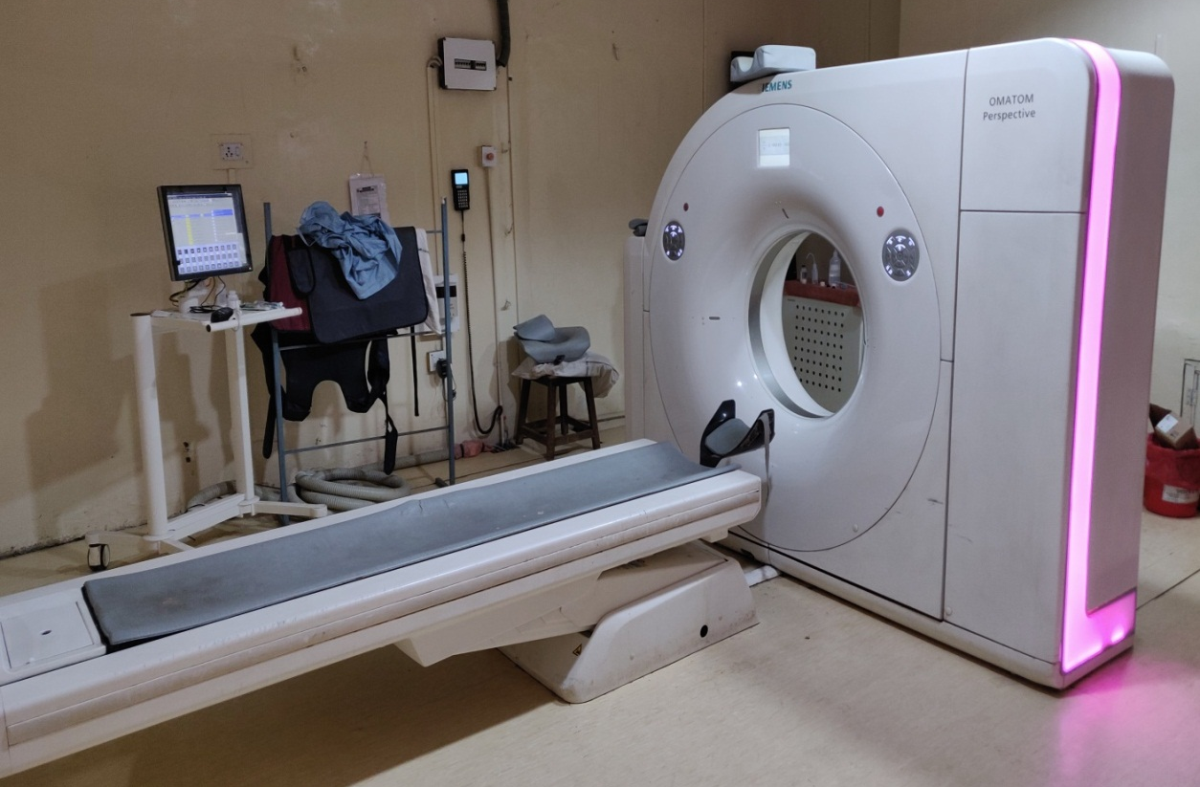
Fig 7: Siemens Somatom Perspective 128 Slice Scanner.

TECHNIQUE

Scan protocol and image reconstruction:
All patients were scanned with a Siemens Somatom Perspective 128 Slice Scannerequipped with a new feature in multislice CT technology, so called z-axis flying focus technology. Due to higher oversampling rate in the z axis, reduces the artifacts related to the spiral acquisition and improving spatial resolution down to 0.4 mm.

Protocol of performing cardiac CT:
Patient preparation:
- NBM for 3 hours.
- All patients were checked for their serum creatinine levels.
- Patients were asked to carry their recent ECG and 2D echocardiography reports along with them for evaluation. (Those patient with poor ejection fraction should receive less quantity of saline chaser)
Preparation on table:
- Hands were raised above the head and ECG leads were fixed.
- Breath-holding technique was practiced on table with patient, as it improves patient compliance, decreases patient anxiety and may lessen artifacts during acquisition. This also is useful to identify any unusual effects that might occur to heart rate and regularity from breath holding in individual patients
- Patients were informed about the experience of diffuse warmth at the end of the injection.
Intravenous injection:
- An intravenous line of 18 no. gauge needle was taken on the right or left forearm.
- Contrast concentration used was350 mg iodine/ml. Normal amount of contrast used was 1.5– 2 ml/kg.
- A saline chaser of 40 ml was used for optimal utilization of contrast and for decreasing the contrast artifact from the SVC and right ventricle.
- Rate of injection was 5-7 ml per second.
- Automated bolus tracking was used for starting the scan.

After the procedure, the patient was kept under observation for 15 to 30 minutes. Patient was asked for adequate hydration to prevent contrast induced nephropathy.
Parameters used for acquiring CT:
- Scan range: From thoracic inlet up to the L1–2 level.
- Collimation:64 × 0.625
- Matrix:512×512
- Slice Thickness:Slice thickness of 3mm and recon increment of 0.75 mm.
- Pitch: Pitch was 0.27.
- Scan time: The scan time on an average was 14 sec.
- Scan direction: The scan direction wascranio-caudal.
- X-ray tube volt120 kV and Tube current was 30-80 mAwas used.
- Image post-processing: Images were reconstructed with ECG gating to obtain optimal, motion-free image quality. Data sets were reconstructed immediately after the scan following a stepwise pattern. Initially, a single data set was reconstructed during the mid to end-diastolic phase (350 ms before the next R wave). In case of persistent artifacts related to coronary motion, a second reconstruction approach was carried out, including reconstruction of data sets during both mid to end diastolic phase (between 60% and 70% of the R-R interval). The reconstruction algorithm uses data from a single heartbeat obtained during half-X-ray tube rotation, resulting in a temporal resolution of 220 ms.

The axial images were generated from the source raw data images. The slice thickness of 3 mm with recon increment of 0.75 mm was used. The images were then transferred to a dedicated on SyngoviaWorkstation for image post-processing techniques. The various techniques used were Multiplanar Reconstruction (MPR), Maximum Intensity Projection (MIP), Curved Planar Reconstruction (CPR) and Volume Rendering Technique (VRT).

STATISTICAL ANALYSIS
Quantitative data is presented with the help of Mean and Standard deviation. Comparison among the study groups is done with the help of the unpaired t test as per results of normality test. A qualitative data is presented with the help of frequency and percentage table. Association among the study groups is assessed with the Fisher test, student ‘t’ test and Chi-Square test. ‘p’ value less than 0.05 is taken as significant.
Pearson's chi-squared test
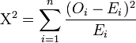
Where Χ2 = Pearson's cumulative test statistic.
Oi = an observed frequency;
Ei = an expected frequency, asserted by the null hypothesis;
n = The number of cells in the table.

The following statistical significance tests would be applied:
1. T test were used to compare two independent groups of continuous data.
2. The “Chi square test” were used to compare categorical data.
3. Test of significance for difference of proportions “|Z|- Test”
4. For finding correlation coefficient “Karl Pearson Correlation Coefficient” was used.
5. 2×2 diagnostic table were used for calculating sensitivity, specificity, positive predictive value, negative predictive value, etc.

Finally, the calculated value was compared with the tabulated value at particular degree of freedom and find the level of significance. A “p-value” is considered non-significant if >0.05 and significant if < 0.05.
Results were graphically represented where deemed necessary.
Appropriate statistical software, including but not restricted to MS Excel, SPSS ver. 20 will be used for statistical analysis. Graphical representation will be done in MS Excel 2010.

OBSERVATIONS AND RESULT

Table 1- Mean Weight, Age and Heart Rate of patients
Variables | N | Minimum | Maximum | Mean | Std. Deviation
Weight (kg) | 40 | 10 | 95 | 42.77 | 26.867
Age | 40 | 2 | 52 | 16.68 | 13.419
HR | 40 | 68 | 130 | 94.1 | 16.043

Mean weight of the study population was 42.77±26.867 kg, mean age was 16.68±13.41 years. Mean heart rate was 94.1±16.04 bpm, range of heart rate was from 68 to 130 bpm.

Graph 1- Mean Weight, Age and heart rate of patients

Table 2 - Mean LVEF, Contrast volume, flow rate, scan time, radiation dose
Variables | N | Minimum | Maximum | Mean | Std. Deviation
LVEF % | 40 | 55 | 66 | 59.62 | 2.752
Contrast volume (mg/ml) | 40 | 300 | 340 | 310 | 12.177
Flow rate (ml/sec) | 40 | 5 | 7 | 5.87 | 0.819
Scan Time (SEC) | 40 | 11 | 17 | 14.03 | 1.368
Radiation dose (millisievert) | 40 | 7 | 12 | 9.6 | 1.958

Mean LVEF% of study population was 59.6±2.7 and mean contrast volume was 310±12.17 mg/ml. Mean flow rate was 5.8±0.8 ml/sec, mean scan time was 14.03±1.3 sec and mean radiation dose was 9.6±1.9 millisievert

Graph 2 - Mean LVEF, Contrast volume, flow rate, scan time, radiation dose

Table 3- Distribution according to Sex
Sex | Number | Percent
Female | 17 | 42.50%
Male | 23 | 57.50%

Male were more (57.5%) than female (42.5%) in our study. Ratio of male: female was 1.4:1

Graph 3- Distribution according to Sex

Table 4 - Distribution according to diagnosis
DIAGNOSIS | Number | Percent
Aorto-Pulmonary window | 1 | 2.50%
ASD | 3 | 7.50%
VSD | 2 | 5.00%
CoA | 5 | 12.50%
Double outlet right ventricle | 2 | 5.00%
PDA | 3 | 7.50%
POF | 3 | 7.50%
TGA | 1 | 2.50%
TOF | 17 | 42.50%
Tricuspid atresia with univentricular heart | 1 | 2.50%
Left isomerism | 1 | 2.50%
Right isomerism | 1 | 2.50%

According to diagnosis TOF was present in 42.5% cases, while CoA was present in 12.5% cases. ASD was present in 7.5% cases,VSD was present in 5% cases. Remaining diagnosis were Aorto-Pulmonary window (2.5%), Double outlet right ventricle (5%), Tricuspid atresia with univentricular heart2.5%, left isomerism (2.5%) and right isomerism (2.5%).

Graph 4 - Distribution according to diagnosis

Table 5- Distribution according to associated anomaly
Associated Anomaly | Number | Percent
Dextrocardia | 2 | 5.00%
Bicuspid aortic valve | 2 | 5.00%
Unilateral absence of pulmonary artery | 1 | 2.50%
Isolated situs inversus | 1 | 2.50%
PDA | 1 | 2.50%
Pulmonary atresia | 1 | 2.50%
Right sided aortic arch | 1 | 2.50%
Persistent left SVC | 1 | 2.50%
Absent pulmonary valve syndrome | 1 | 2.50%
Coronary artery anomaly | 1 | 2.50%
None | 28 | 70.00%

Associated anomalies of study population were Dextrocardia (5%), bicuspid aortic valve (5%), Unilateral absence of pulmonary artery (2.5%), Isolated situs inversus (2.5%), PDA (2.5%), pulmonary atresia (2.5%), right sided aortic arch (2.5%), Persistent left SVC (2.5%), Absent pulmonary valve syndrome (2.5%),Coronary artery anomaly (2.5%).

Graph 5 - Distribution according to associated anomaly

Table 6- Distribution of Congenital heart disease according to sedation, cardiac catheterization and cyanosis of patients
Sedation | Number | Percent
No | 27 | 67.50%
Yes | 13 | 32.50%
Cardiac Cath | Number | Percent
No | 32 | 80.00%
Yes | 8 | 20.00%
Cyanosis | Number | Percent
No | 19 | 47.50%
Yes | 21 | 52.50%

Sedation was done in 32.5% cases, cardiac catheterization was done in 20% cases and cyanosis was present in 52.5% cases.

Graph 6 (a)- Distribution Congenital heart disease according to sedation of patients

Graph 6 (b)- Distribution of Congenital heart disease according to cardiac catheterization of patients

Graph 6 (c) - Distribution of Congenital heart disease according to cyanosis of patients

Table 7- Association of gender with cardiac catheterization of patients
Sex | No | Yes
Female | 14 | 3
Male | 18 | 5
Fischer exact test | 0.102 | P value=0.749

No significant association was present between gender and cardiac catheterization. 5 males and 3 females had undergone cardiac catheterization.

Graph 7- Association of gender with cardiac catheterization of patients

Table 8 - Association of diagnosis with cardiac catheterization of patients
Diagnosis | No | Yes
Aorto-pulmonary window | 1 | 0
ASD | 3 | 0
VSD | 2 | 0
COA | 5 | 0
Double outlet right ventricle | 2 | 0
Left isomerism | 1 | 0
PDA | 3 | 0
Pentalogy of Fallot | 1 | 2
Right isomerism | 0 | 1
TGA | 1 | 0
TOF | 13 | 4
Tricuspid atresia with univentricular heart | 0 | 1
Fischer exact test | 16.716 | P value=0.03

Significant association was present between cardiac catheterization and diagnosis. 2 cases with cardiac catheterization had pentalogy of Fallot, 1 case had right isomerism and had undergone cardiac catheterization. 4 cases with TOF and 1 case of tricuspid atresia with univentricular heart had cardiac catheterization.

Graph 8 - Association of diagnosis with cardiac catheterization of patients

Table 9 - Association of associated anomaly with cardiac catheterization of patients
Associated Anomaly | No | Yes
Dextrocardia | 1 | 1
Bicuspid aortic valve | 2 | 0
Unilateral absence of pulmonary artery | 1 | 0
Isolated situs inversus | 0 | 1
PDA | 1 | 0
Pulmonary atresia | 1 | 0
Right sided aortic arch | 1 | 0
Persistent left SVC | 1 | 0
Absent pulmonary valve syndrome | 1 | 0
Coronary artery anomaly | 1 | 0
None | 22 | 6
Fischer exact test | 7.411 | P value=0.686

No significant association was found between associated anomaly and cardiac catheterization.

Graph 9 - Association of associated anomaly with cardiac catheterization of patients

Table 10- Association of sedation and cyanosis with cardiac catheterization of patients
Sedation | No | Yes
No | 23 | 4
Yes | 9 | 4
Fischer exact test | 1.396 | P value=0.237
Cyanosis | No | Yes
No | 17 | 2
Yes | 15 | 6
Fischer exact test | 2.03 | P value=0.0154

No significant association was found between sedation and cardiac catheterization, while significant association was found between cyanosis and cardiac catheterization. 6 cases had cyanosis and undergone cardiac catheterization while 4 cases were having sedation and had undergone cardiac catheterization.

Graph 10(a)- Association of sedation with cardiac catheterization of patients

Graph 10 (b)- Association of cyanosis with cardiac catheterization of patients

DISCUSSION
The present descriptive cross-sectional observational study was done on 40 patients at our tertiary care Centre to study the various Congenital Heart Diseases using Cardiac Computed Tomography (CT).

CHD may be diagnosed at virtually any age. Certain conditions are usually discovered in neonatal period; other conditions are identified during infancy or childhood⁹⁵. CHD is the most common cause of the major congenital anomalies, representing a major global health problem. The estimated prevalence of CHD is 8 per 1000 live births⁹⁶.

Cardiac CT is an important tool in the evaluation of congenital heart disease (CHD). Cardiac CT can be used for accurate depiction of complex cardiovascular anatomic features. CT facilitates the assessment of extra-cardiac systemic and pulmonary arterial and venous structures. It is important for radiologists to have extensive knowledge of cardiovascular anatomy, physiology, and surgical techniques¹³.

Cardiac catheterization remains the gold standard for direct hemodynamic assessment. Frequency of cardiac imaging varies by CHD subgroup, patient age, clinical status, surgical palliation, other cardiac interventions and residual hemodynamic anatomic defects^{97,98}.

Compared with CT of the past, 16-MDCT and newer scanners yield images with better temporal and spatial resolution, greater anatomic coverage per rotation, more consistent enhancement with a lesser volume of intravascular contrast material, and higher-quality 2D reformation and 3D reconstruction owing to acquisition of an isotropic data set¹⁸⁻¹⁹. Rapid imaging with these CT scanners requires less patient sedation than older-generation CT and conventional angiography^{18,99}.

Although the role of CT in the evaluation of pediatric CHD is being redefined and expanded, there are several generally accepted clinical indications for which the benefits of imaging outweigh the risks. First, CT can be used to evaluate patients with CHD known or suspected on the basis of echocardiographic findings for which further imaging is needed to characterize associated extra-cardiac anomalies before intervention. The pulmonary arteries, pulmonary veins, and aortic arch and great vessels may be inadequately characterized by echocardiography, necessitating further assessment with CT¹⁵. Second, CT can be used in the postoperative evaluation of CHD patients who have a variety of suspected treatment-related complications²⁰. Finally, CT can be useful before a reoperation to assess altered anatomic features related to previous surgery²⁰.

In the present study, mean weight of the study population was 42.77±26.867 kg, mean age was 16.68±13.41 years, mean heart rate was 94.1±16.04 bpm and range of heart rate was from 68 to 130 bpm. The mean LVEF of study population was 59.6±2.7 % and mean contrast volume was 310±12.17 mg/ml, mean flow rate was 5.8±0.8 ml/sec, mean scan time was 14.03±1.3 sec and mean radiation dose was 9.6±1.9 millisievert. Male were more (57.5%) than female (42.5%) in our study. Ratio of male:female was 1.4:1.This is similar to the studies by Meshram RM et al¹⁰⁰ and Marelli AJ et al¹².

Meshram RM et al¹⁰⁰ prospective, observational study assessing the prevalence and pattern of congenital heart disease (CHD) observed that CHD was more common in male (56.98%) giving rise to a male:female ratio was 1.3:1.

Marelli AJ et al¹² study determining the prevalence, age, and proportion of children and adults with CHD found females accounted for 52% and 57% of the CHD population in children and adults, respectively. The proportion of females in the CHD population was significantly higher 57% versus 51% in adults (P<0.0001) and 52% versus 49% in children (P<0.0001). The prevalence of all CHD in adults was significantly higher in females than in males (4.55 per 1000 females versus 3.61 per 1000 males; P<0.0001). In those with severe disease, the prevalence was higher in female adults (0.41 per 1000 versus 0.35 per 1000; P=0.0001) than male children.

According to diagnosis in our study TOF was present in 42.5% cases, while CoA was present in 12.5% cases, ASD was present in 7.5% cases, PDA was present in 7.5% cases, POF was present in 7.5% cases, VSD was present in 5% cases. Remaining diagnosis were Aorto-pulmonary window (2.5%), Double outlet right ventricle (5%), Tricuspid atresia with univentricular heart (2.5%), TGA (2.5%), Left isomerism (2.5%) and Right isomerism (2.5%). This is comparable to the studies of Meshram RM et al¹⁰⁰, Zahid BS et al¹⁰¹ and Marelli AJ et al¹².

Meshram RM et al¹⁰⁰ prospective, observational study assessing the prevalence and pattern of congenital heart disease (CHD) found 287 (66.74%) patients were diagnosed with acyanotic type of CHD while 143 (33.26%) were cyanotic type. The most common CHD was VSD 129 (30.01%), followed by ASD 89 (20.70%), TOF 69 (16.05%), and PDA 44 (10.23%), respectively. The most common cyanotic CHD was TOF followed by transposition of great vessels, total anomalous pulmonary venous connection, and single ventricle.

Zahid BS et al¹⁰¹ study reported 52.8% acyanotic and 47.2% cyanotic congenital heart diseases. VSD (30.01%) was the most common CHD, followed by ASD (20.70%), TOF (16.05%), and PDA (10.23%). VSD was the most common acyanotic CHD while TOF was the most common cyanotic CHD.

Associated anomalies of present study population were Dextrocardia (5%), bicuspid aortic valve (5%), Unilateral absence of pulmonary artery (2.5%), Isolated situs inversus (2.5%), PDA (2.5%), pulmonary atresia (2.5%), Right sided aortic arch (2.5%), Coronary artery anomaly (2.5%), Persistent left SVC (2.5%) and Absent pulmonary valve syndrome (2.5%). This is concordant to the studies of Meshram RM et al¹⁰⁰, Dabizzi RP et al⁶⁵, Aravind S et al¹⁰², Saxena A et al¹⁰³ and Sedaghat F et al¹⁰⁴.

Dabizzi RP et al⁶⁵ observed approximately 36% of tetralogy of Fallot patients have an anomaly in the origin and course of a coronary artery, such as single coronary ostium, left anterior descending artery originating from the right coronary artery, and circumflex artery originating from the right coronary artery⁶⁶.

Aravind S et al¹⁰² study reported extracardiac anomalies in 21.42% of patients. Saxena A et al¹⁰³ study reported a higher incidence of transposition of great vessels, single ventricle, total anomalous pulmonary venous connection, and double outlet right ventricle.

Sedaghat F et al¹⁰⁴ study determining the diagnostic value of CT in the cardiac anomalies reported non-cardiac abnormalities in the thoracic or abdominal organs including situs inversus / ambiguus (n=4) and aberrant right subclavian artery (n=2).

Atrial septal defect (ASD) is the most common CHD in adults and is often undiagnosed until adulthood, due to a lack of early symptoms and paucity of physical findings. Depending on the location several types of ASDs can be distinguished and several associated lesions may exist. The secundum ASD is by far the most common type of ASDs, which is localized centrally in the inter-atrial septum.

In our study, sedation was done in 32.5% cases, cardiac catheterization was done in 20% cases and cyanosis was present in 52.5% cases. This is consistent with the study by Bret-Zurita M et al¹⁰⁵.

Bret-Zurita M et al¹⁰⁵ observational retrospective cohort study analyzing the clinical application of 64-MDCT in pediatric CHD patients reported catheterization was performed in only 12.5% of patients. Of the patients studied, 90% had moderate to severe CHD and 80.2% had a level of complexity < 3 (level I). There were new findings in 77% of patients (82.9% with complex disease), which prompted a change in patient management in 35.6%.

The need for sedation can vary depending on patient characteristics, CT scanner speed, and exam goals. For many CTs, developmentally appropriate older children, typically over the age of 4 years, can remain motionless in the scanner and by 6 or 7 years can cooperate with breath hold instructions¹⁰⁶. Of note, children with cyanotic CHD are well-documented to have a high incidence of neurodevelopmental abnormalities and genetic syndromes, which should be determined before the study^{107,108}. For infants under 6 months “feed and wrap” method can be used. However, particularly in studies focusing more on extra-cardiac structures such as the aortic arch or pulmonary arteries or veins, whose images are less motion-sensitive, we find that even toddlers and preschool-aged children may be scanned without sedation if tightly wrapped or placed in a vacuum immobilizer device. Child life therapists are often involved for support, and a parent wearing appropriate shielding can remain in the room when possible during the scan.

Cardiac CT has been utilized to diagnose and manage a broad spectrum of cyanotic and acyanotic cardiac defects by delineating anatomic details, assessing cardiac relationships to extra-cardiac structures, and identifying post-intervention complications¹⁰⁹.

Cardiac catheterization remains the gold standard for visualizing the entire coronary system and for the diagnosis/exclusion of coronary artery disease. However, cardiac CT is increasingly being used as a noninvasive alternative for the evaluation of coronaries in CHD^{35,106,110}.
The use of catheterization has evolved in the past few decades away from solely obtaining diagnostic information towards its main contemporary use for therapeutic interventions in CHD patients. Heart catheterization is still the gold standard for intra-cavity and intravascular pressure measurements. Moreover, right heart catheterization is the only way to confirm pulmonary arterial hypertension and pulmonary vascular disease¹¹¹.
It was observed in the present study that no significant association was present between gender and cardiac catheterization. 5 male and 3 female CHD patients had undergone cardiac catheterization. Significant association was present between cardiac catheterization and diagnosis of CHD. 2 cases with cardiac catheterization had pentalogy of fallot, 1 case had right isomerism and had undergone cardiac catheterization. 4 cases with TOF and 1 case of tricuspid atresia with univentricular heart had cardiac catheterization. This is in concordance to the study of Bret-Zurita M et al¹⁰⁵.

TOF is the most common form of cyanotic CHD, accounting for 5% of congenital heart defects¹¹². In TOF, anterior deviation of the conal portion of the ventricular septum obstructs blood flow through the RV outflow tract and directs desaturated blood though a ventricular septal defect into the systemic circulation. RV outflow tract obstruction falls along a spectrum ranging from minimal sub pulmonary stenosis to pulmonary atresia or, in its most severe form, absent main and branch pulmonary arteries with multiple aortopulmonary collateral arteries (MAPCAs) arising from the aortic arch to feed the lungs. Preoperatively, most of the TOF anatomy can be determined by echocardiogram. However, an estimated 5% to 12% of these patients suffer from coronary artery abnormalities, such as an accessory left anterior descending coronary arising from the right coronary and crossing the pulmonary outflow tract, which can preclude a full neonatal repair¹¹³⁻¹¹⁵. CT has been shown to identify coronary anomalies in young children with unrepaired TOF with 97% to 100% sensitivity and specificity.

During the newborn period, cardiac catheterization may be delayed until the patient is older, decreasing risk of vessel injury. When preoperative catheterization is performed, usually at a few months of age, CT images guide the procedure, which focuses on identifying aortopulmonary collateral stenosis and dual sources of pulmonary blood flow. Fewer angiograms can be performed, limiting radiation and contrast exposure.

It was observed in our study that no significant association was found between associated anomaly and cardiac catheterization. Greil GF et al⁶⁷ noted similar observation in their study.

Greil GF et al⁶⁷ observed Oblique reformatted images can be used to establish accurate measurements of the luminal diameter of the pulmonary artery that correlate highly with findings at cardiac catheterization.

Anomalous coronary disease, cardiac CT enables assessment of several anatomic and prognostic features, including coronary ostial narrowing, acute angulation, and an interarterial course³⁸⁻⁴⁰. Understanding coronary relationships to surrounding structures is also important before percutaneous pulmonary valve implantation because stent expansion can lead to coronary compression and ischemia. Coronary imaging is best performed at heart rates <60 bpm to maximize image quality. Lower heart rates can be achieved safely in children with β-blockers⁴¹, although caution is required in patients with conduction disease and heart failure.

In the present study, no significant association was found between sedation and cardiac catheterization, while significant association was found between cyanosis and cardiac catheterization. 6 cases had cyanosis and undergone cardiac catheterization. This finding was consistent with the study by O’Byrne ML et al¹¹⁶.

Gao W et al¹¹⁷ study assessing the diagnostic accuracy of sub-mSv low-dose prospective ECG-triggering cardiac CT (CCT) in young infants with complex congenital heart disease (CHD) reported detection rate for the origins of the left and right coronary arteries was 96 and 90 %, respectively.

Eichhorn JG et al¹¹⁸ study found multidetector CT has high diagnostic accuracy, avoiding the need for additional techniques to plan the surgical approach. The diagnostic accuracy of CT is comparable to catheterization and is more accurate in detecting other complications that could put the patient's life at risk.

Khatri S et al¹¹⁹ suggested that 64-MDCT has many advantages over other conventional diagnostic techniques and that it provides key data concerning the surgical and interventional approach to adopt. Juan CC et al¹²⁰ suggested that although 64-MDCT is good diagnostic technique in CHD, because of its lack of a therapeutic role it cannot replace catheterization.
CT also is useful in the evaluation of postoperative complications, including stenosis and aneurysm formation at the repair site and extrinsic compression of the left mainstem bronchus between the right pulmonary artery and descending thoracic aorta (a cause of persistent atelectasis)^{66,87}. Two-dimensional reformatted and 3D reconstructed images can assist in the preoperative and postoperative evaluation of this condition⁸⁶⁻⁸⁸.

Coarctation of the aorta can occur anywhere along the course of the vessel. Coarctation is most commonly manifested as a diaphragm-like ridge in a juxta ductal location⁸⁹. In addition to discrete narrowing, associated hypoplasia may be present and involve a portion or all of the aortic arch. At CTA exact delineation of the location and extent of narrowing is extremely useful in pretreatment assessment and for determining whether a patient is to be treated with surgery, angioplasty, or stent placement.

Invasive diagnostic cardiac catheterization studies should only be undertaken once other non-invasive imaging modalities have been used exhausted. It is then primarily required for hemodynamic assessment rather than imaging. Specific indications for invasive assessment remain the measurement of pulmonary vascular resistance, the evaluation of coronary arteries, and collateral vessels. Invasive assessment of systolic and end-diastolic ventricular function, pressure gradients, as well as shunts remains reserved for patients in whom non-invasive evaluation leaves uncertainty and the information is critical for clinical decision-making.

Although diagnostic cardiac catheterization continues to be performed, many patients with simple congenital cardiac defects now undergo surgery based on non-invasive preoperative evaluation alone. Technical advances in echocardiography, cardiac CT, and MRI have been significant, and further advances will likely expand the roles of these techniques in the evaluation of CHD and diminish the need for invasive diagnostic cardiac catheterization.

SUMMARY

The present Descriptive Cross-Sectional Observational study was done on 40 patients at our tertiary care centre to study the various Congenital Heart Diseases using Cardiac Computed Tomography (CT) and assess the morphological details of congenital heart diseases before surgery with CT findings. The following observations were noted:

- Mean weight of the study population was 42.77±26.867 kg, mean age was 16.68±13.41 years.

- Mean heart rate was 94.1±16.04 bpm, range of heart rate was from 68 to 130 bpm.

- Mean LVEF% of study population was 59.6±2.7 and mean contrast volume was 310±12.17 mg/ml.

- Mean flow rate was 5.8±0.8 ml/sec, mean scan time was 14.03±1.3 sec and mean radiation dose was 9.6±1.9 millisievert

- Male were more (57.5%) than female (42.5%) in our study. Ratio of male: female was 1.4:1

- According to diagnosis TOF was present in 42.5% cases, while CoA was present in 12.5% cases.

- ASD was present in 7.5% cases,POF was present in 7.5% cases,PDA was present in 7.5% cases, VSD was present in 5% cases.

- Remaining diagnosis were Aorto-pulmonary window (2.5%), Double outlet right ventricle (5%), tricuspid atresia with univentricular heart 2.5%, TGA (2.5%),left isomerism (2.5%) and right isomerism (2.5%).

- Associated anomalies of study population were Dextrocardia (5%), bicuspid aortic valve (5%), Coronary artery anomaly (2.5%), Unilateral absence of pulmonary artery (2.5%), PDA (2.5%), pulmonary atresia (2.5%), right sided aortic arch (2.5%), Isolated situs inversus (2.5%), Absent pulmonary valve syndrome (2.5%) and Persistent Left SVC (2.5%).

- Sedation was done in 32.5% cases; cardiac catheterization was done in 20% cases and cyanosis was present in 52.5% cases.

- No significant association was present between gender and cardiac catheterization. 5 males and 3 females had undergone cardiac catheterization

- Significant association was present between cardiac catheterization and diagnosis. 2 cases with cardiac catheterization had pentalogy of fallot, 1 case had right isomerism and had undergone cardiac catheterization. 4 cases with TOF and 1 case of tricuspid atresia with univentricular heart had cardiac catheterization.

- No significant association was found between associated anomaly and cardiac catheterization.

- No significant association was found between sedation and cardiac catheterization, while significant association was found between cyanosis and cardiac catheterization. 6 cases had cyanosis and undergone cardiac catheterization while 4 cases were having sedation and had undergone cardiac catheterization.

CONCLUSION

- CT accurately depicts simple and complex congenital cardiovascular anomalieswith CT scan findings and it is particularly valuable in the assessment of extra-cardiac vascular anomalies, to see Major aorto-pulmonary collaterals arteries (MAPCAS).
- CT provides complete evaluation of different anatomic structures, including the heart, pulmonary and systemic thoracic vasculature and lungs before surgery.
- Due to the recent advances in MDCT scanners, the need of diagnostic cardiac catheterization has reduced significantly in most of the patients suffering from congenital heart diseases; some complex congenital heart diseases may require further evaluation by diagnostic cardiac catheterization.

Representative Cases
All the findings of the cases studied were tabulated using Microsoft Excel. This is depicted in the master chart which has been added in the annexure. Few of the representative cases have been discussed in detail along with their representative images.
Case 1
Age : 34 years
Sex : Female
CT scan Findings:
Coarctation of Aorta
The narrowing is located just distal to the left subclavian artery with associated bicuspid aortic valve.

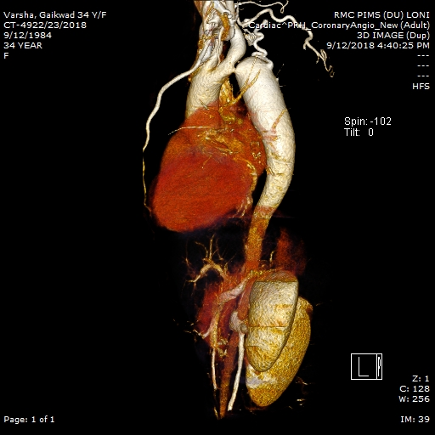
Fig no 8: COA

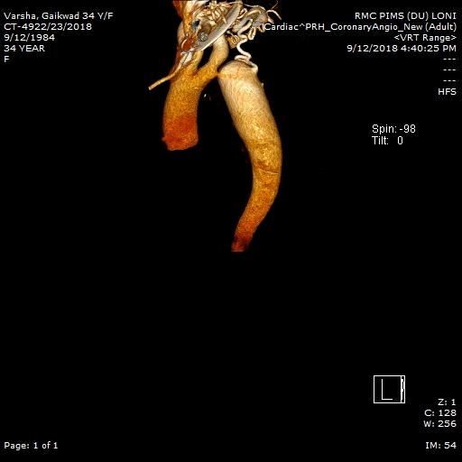
Fig no 9 : Major Aorto-pulmonary collaterals artery

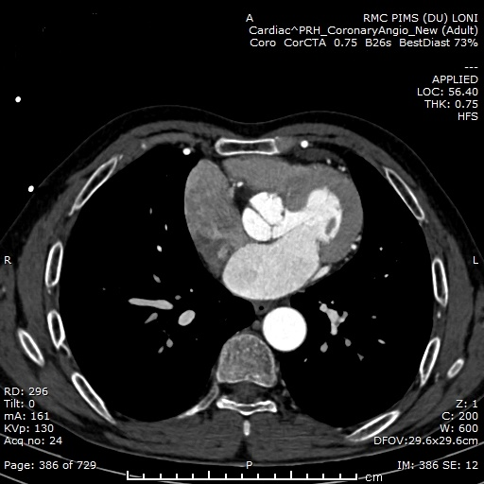
Fig no 10: Associated Bicuspid aortic valve with COA

Fig no 11: COA

Case 2
Age : 15 years
Sex : Male
CT scan Findings:
Aortopulmonary Window
Aortopulmonary window is a communication between the ascending aorta and the pulmonary trunk in the presence of separate aortic and pulmonary valves.
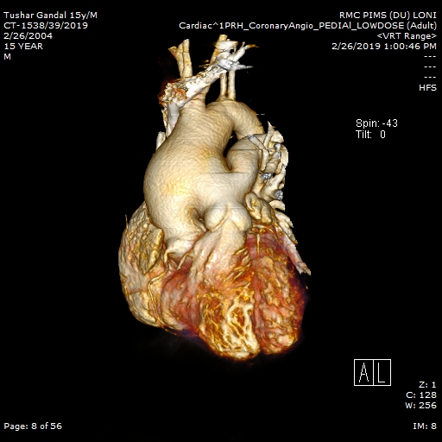
Fig no 12: Aorto-pulmonary window

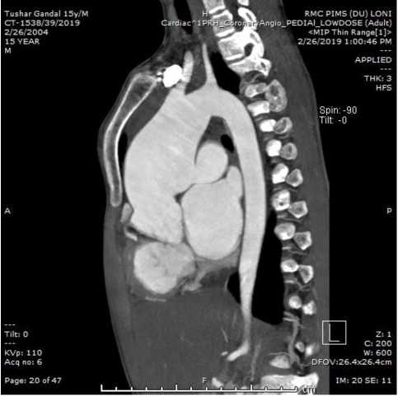
Fig no 13 : Aorto-pulmonary window

Case 3
Age : 6 years
Sex : Female
CT scan Findings:
Patent Ductus Arteriosus.'
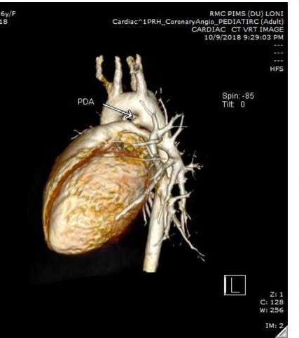
Fig no 14: PDA

Case 5
Age :6 years
Sex : Female
CT scan Findings:
Tricuspid atresia with univentricular heart with persistent left SVC —
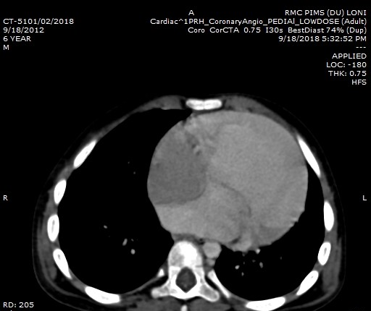

Fig no 15: Tricuspid atresia with single ventricle

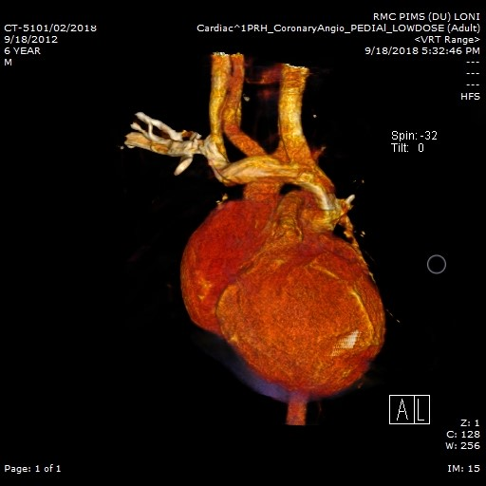

Fig no 16: Persistent Left SVC

Case 6
Age : 5 years
Sex : Female
CT scan Findings:
Tetralogy of Fallot—The morphologic features of tetralogy of Fallot include subpulmonary infundibular stenosis, ventricular septal defect (VSD), overriding of the aorta, and right ventricular hypertrophy
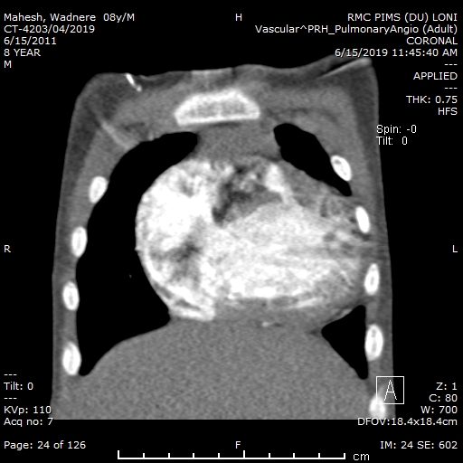
Fig no 17: Subpulmonary infundibular stenosis

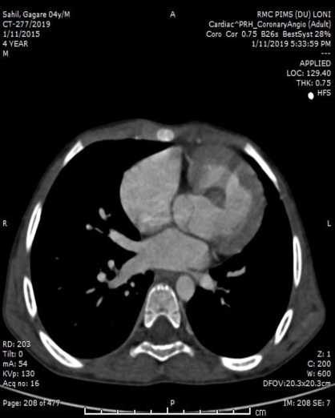
Fig no 18: Large sizedposterior muscular VSD

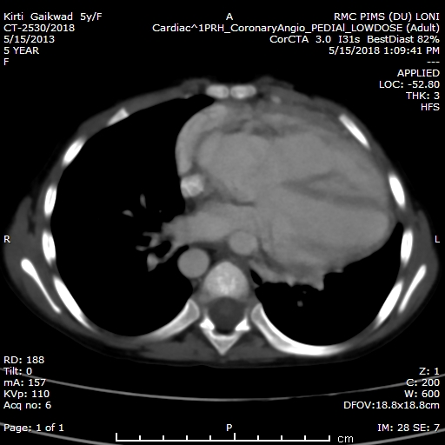

Fig no 19:Overriding of aorta

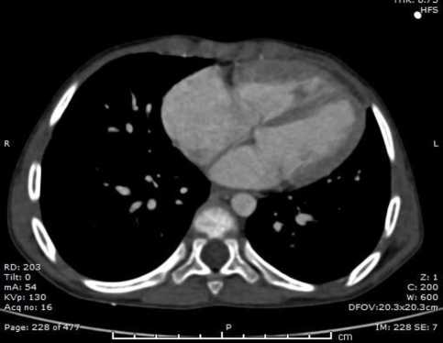
Fig no 19: Right ventricular hypertrophy

Case 7
Age : 18 years
Sex : Male
CT scan Findings:
Absent pulmonary valve syndrome with absent left pulmonary arteryin a patient with TOF

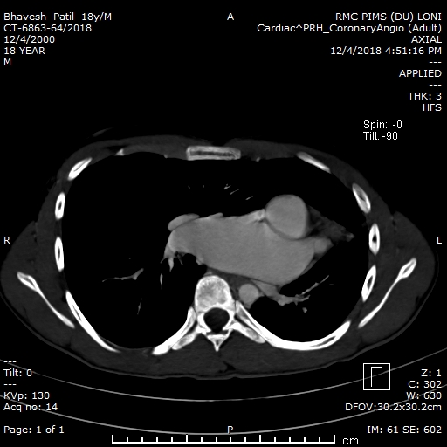
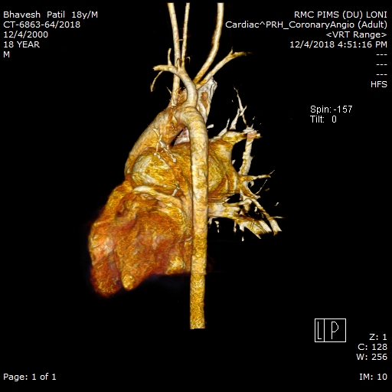

(a) (b)
Fig no20:( a) & (b) Absent pulmonary valve syndrome with absent left pulmonary arteryin a patient with TOF

Case 7
Age : 4 years
Sex : Male
CT scan Findings:
Large sized PDA , in a patient with TOF ,feeding the branch Pas at the level of pulmonary bifurcation

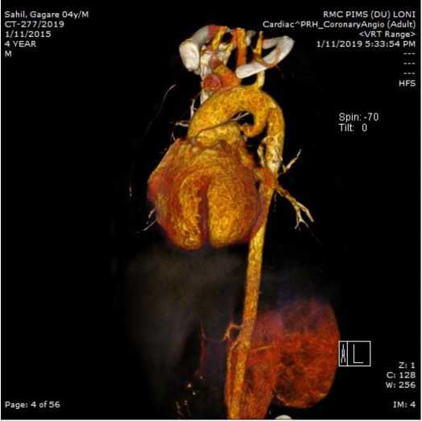
Fig no 21: Large PDA

Case 9
Age : 25 years
Sex : Female
CT scan Findings:
TOF with major aorto-pulmonary collaterals arteries
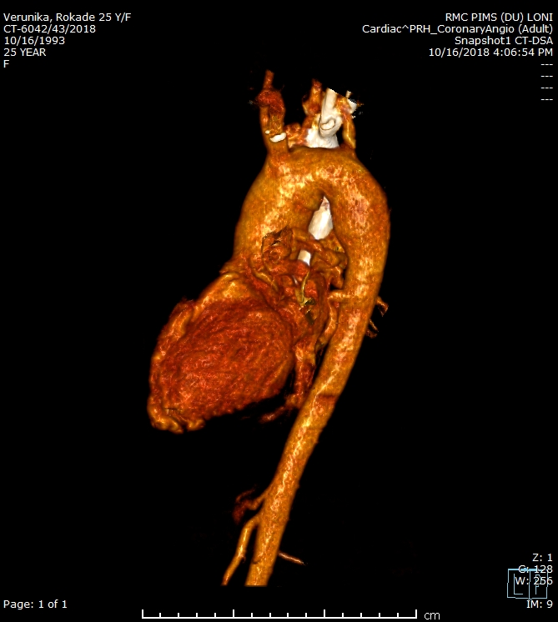
Fig no 22:Major aorto-pulmonary collateral artery

Case 10
Age :2 years
Sex :Male
CT scan Findings:
Coronary artery anomaly in a patient with TOF
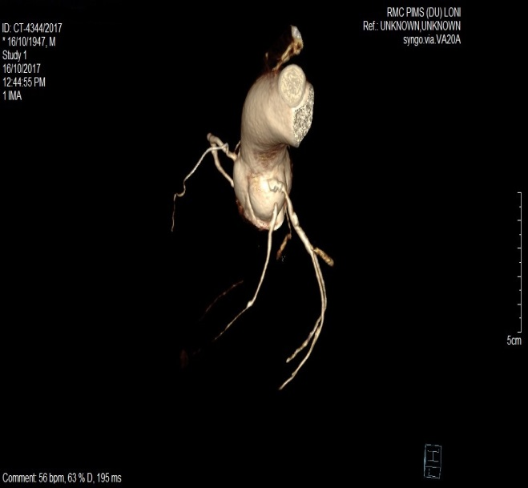
Fig no23:LAD and LCX separate origin (MPR)

Case 11
Age :8 years
Sex :Male
CT scan Findings:
Ventricular Septal Defect with Right sided aorta
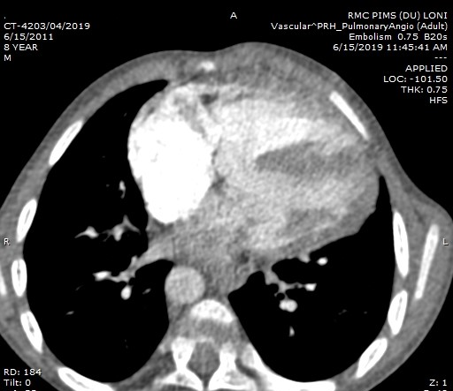
Fig no 24: VSD
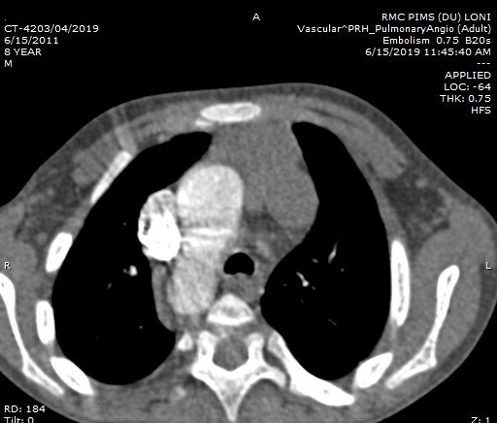
Fig no 25: Right sided aortic arch

Case 12
Age :18 years
Sex : Female
CT scan Findings: Double outlet right ventricle with dextrocardia with severe infundibular narrowing of pulmonary artery , perimembranous VSD and Common atria
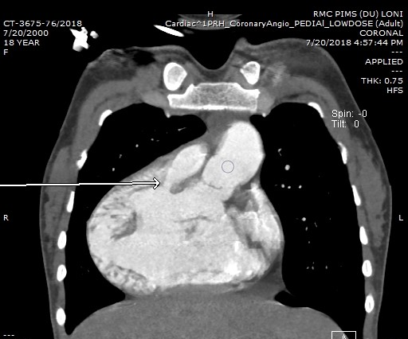
Fig no 27 : Double outlet right ventricle

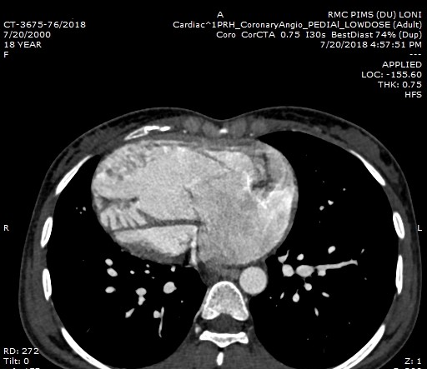
Fig no 26: Dextrocardia

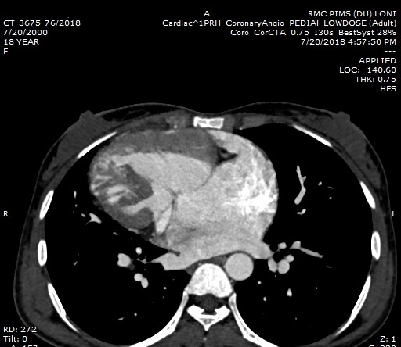
Fig no 28 : Perimembranous VSD with common Atrium

Fig no : Severe infundibular narrowing

Case 12
Age :14 years
Sex : Male
CT scan Findings:
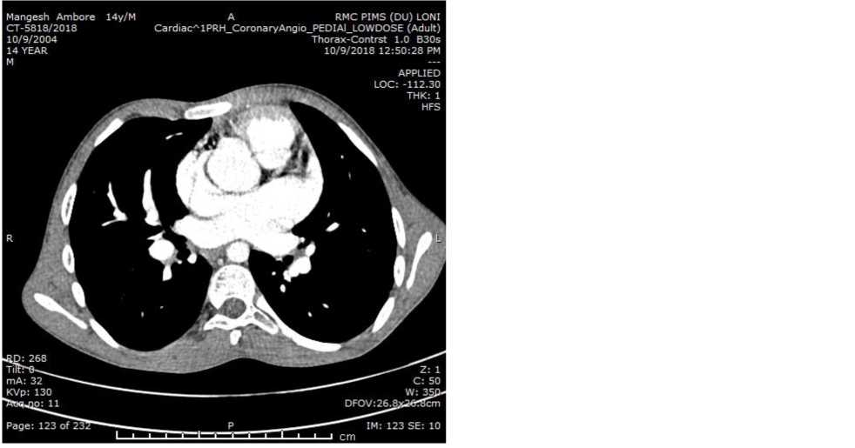
Fig no 29 :Moderate sized sinus venosus ASD of SVC type

Case 13
Age : 12 years
Sex :Male
CT scan Findings:
Left Atrial Isomerism with Isolated situs inversus
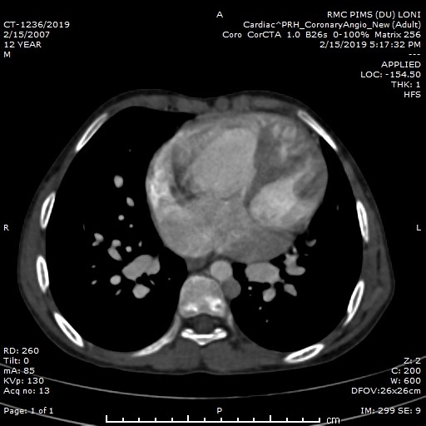
Fig no 30 : Bilateral Left atria

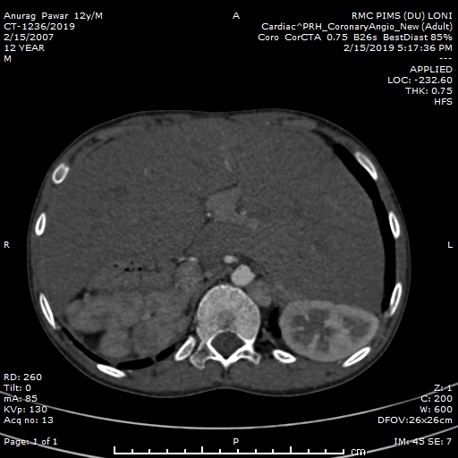
Fig no. 31 : Polysplenia with Isolated situs inversus

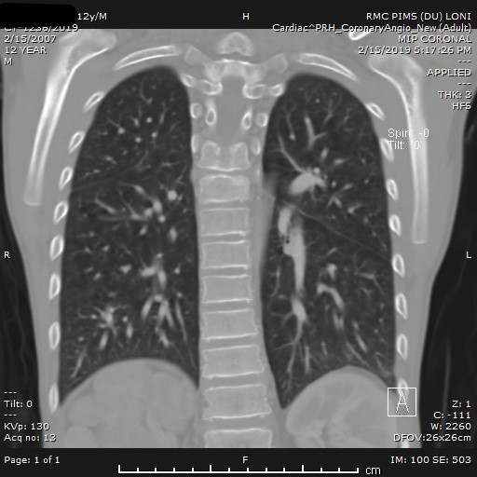

Fig no 32: Bilobed lung

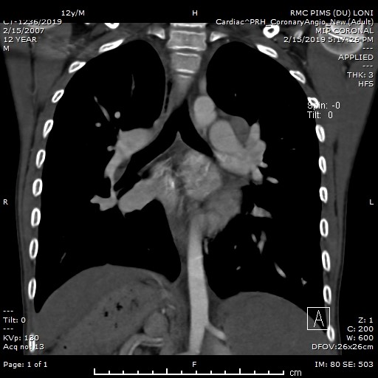
Fig no 33 : Bilateral hyparterial bronchi

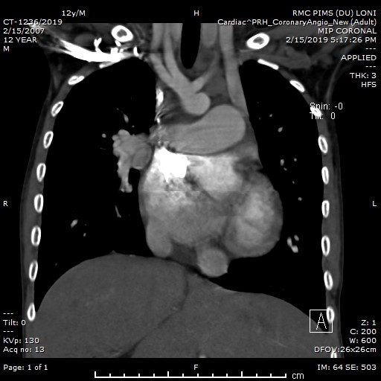

Fig no 34 : Persistent left SVC

REFERENCES
- "Other Names for Congenital Heart Defects". July 1, 2011. Archived from the original on 27 July 2015. Retrieved 10 August 2015.
- Mendis S, Puska P, Norrving B. World Health Organization. Global Atlas on Cardiovascular Disease Prevention and Control (PDF). World Health Organization in collaboration with the World Heart Federation and the World Stroke Organization. 2011, pp. 3, 60.
- "What Are Congenital Heart Defects?". National Heart, Lung, and Blood Institute. July 1, 2011. Archived from the original on 13 August 2015. Retrieved 10 August 2015.
- "What Are the Signs and Symptoms of Congenital Heart Defects?". National Heart, Lung, and Blood Institute. July 1, 2011. Archived from the original on 27 July 2015. Retrieved 10 August 2015.
- Warnes CA, Liberthson R, Danielson GK et al. Task Force 1: the changing profile of congenital heart disease in adult life. J Am Coll Cardiol. 2001; 37: 1170–1175.
- Hoffman JI, Kaplan S. The incidence of congenital heart disease. J Am Coll Cardiol. 2002, 39: 1890–1900.
- Botto LD, Correa A, Erickson JD. Racial and temporal variations in the prevalence of heart defects. Pediatrics. 2001, 107: E32.
- Ferencz C, Rubin JD, McCarter RJ et al. Congenital heart disease: prevalence at livebirth: the Baltimore-Washington Infant Study. Am J Epidemiol. 1985, 121: 31–36.
- Fyler DC. Report of the New England Regional Infant Cardiac Program. Pediatrics. 1980, 65: 375–461.
- Perloff JK. Congenital heart disease after childhood: an expanding population: 22nd Bethesda Conference. J Am Coll Cardiol. 1991, 18: 311–342.
- Webb GD, Williams RG. Care of the adult with congenital heart disease: introduction. J Am Coll Cardiol. 2001, 37: 1166.
- Marelli AJ, Mackie AS, Ionescu-Ittu R et al. Anita Saxena Congenital Heart Disease in India: A Status Report, Indian Journal of Pediatrics, Volume 72 July 2005. 2. Congenital Heart Disease in the General Population: Changing Prevalence and Age Distribution. Circulation. 2007, 115:163-72.
- Gaca AM, Jaggers JJ, Dudley LT et al. 3rd. Repair of congenital heart disease: a primer. Part 1. Radiology. 2008, 247:617-631
- Tsai IC, Chen MC, Jan SL et al. Neonatal cardiac multidetector row CT: why and how we do it. Pediatr Radiol. 2008, 38:438-451
- Leschka S, Oechslin E, Husmann L et al. Pre- and postoperative evaluation of congenital heart disease in children and adults with 64-section CT. RadioGraphics. 2007, 27:829-846
- Hollingsworth CL, Yoshizumi TT, Frush DP et al. Pediatric cardiac-gated CT angiography: assessment of radiation dose. AJR. 2007, 189:12-18
- Mehta R, Lee KJ, Chaturvedi R et al. Complications of pediatric cardiac catheterization: a review in the current era. Catheter Cardiovasc Interv. 2008, 72:278-285
- Siegel MJ. Multiplanar and three-dimensional multi-detector row CT of thoracic vessels and airways in the pediatric population. Radiology. 2003, 229:641-650
- Spevak PJ, Johnson PT, Fishman EK. Surgically corrected congenital heart disease: utility of 64-MDCT. AJR. 2008, 191:854-861
- Bean MJ, Pannu H, Fishman EK. Three-dimensional computed tomographic imaging of complex congenital cardiovascular abnormalities. J Comput Assist Tomogr. 2005, 29:721-724
- Lee T, Tsai IC, Fu YC et al. Using multidetector-row CT in neonates with complex congenital heart disease to replace diagnostic cardiac catheterization for anatomical investigation: initial experiences in technical and clinical feasibility. Pediatr Radiol. 2006, 36:1273-1282
- Kawano T, Ishii M, Takagi J et al. Three-dimensional helical computed tomographic angiography in neonates and infants with complex heart disease. Am Heart J. 2000, 139:654-660.
- Moon Y, Kim YM, Kim TH et al. Congenital anomalies of aortic arch: CT angiography. J Korean Radiol Soc. 2001, 44:51-58.
- Becker C, Soppa C, Fink U et al. Spiral CT angiography and 3D reconstruction in patients with aortic coarctation. Eur Radiol. 1997, 7:1473- 1477.
- Haramati LB, Glickstein FS, Issenberg HF et al. MR imaging and CT of vascular anomalies and connections in patients with congenital heart disease: significance in surgical planning. RadioGraphics. 2002, 22:337-349.
- Lim C, Kim WH, Kim SC et al. Truncus arteriosus with coarctation of persistent fifth aortic arch. Ann Thorac Surg. 2002, 74:1702-1704.
- Srivastava D. "Making or breaking the heart: from lineage determination to morphogenesis". Cell. 2006, 126 (6): 1037–48.
- Larsen, William J. "7. Development of the Heart". Human Embryology. Churchill Livingstone. 1993.
- Rokitarisky KE. Die defecte der Scheidewande des Herzens. Wien. 1875.
- Spitzer A. Arch. Pathol. Anat. 1923, 243, 81–272.
- Krimski LD. Pathological anatomy of congenital heart defects and complications after their surgical treatment. M., Medicine.1963.
- Grebbe P, Hirvonens L, Lind J, Wegelius C. Cineangiocardiographic recordings of the cyclic changes in volume of the left ventricle. Cardiologia 1959;34:348.
- Baily NA, Crepeau RL, Lasser EC. Fluoroscopic tomography. Invest Radiol 1974;9:94–103.
- Wood EH, Sturm RE, Sanders JJ. Data processing in cardiovascular physiology with particular reference to roentgen videodensitometry. Proc Mayo Clin 1964;39:849–65.
- Wood EH. Diagnostic applications of indicatordilution technics in congenital heart disease. Circ Res 1960;10:209–40.
- Ziedses des Plantes BG. Das Electronische Subtractions Verfahren. Elektromedica 1968;23:1.
- Robb RA, Johnson SA, Greenleaf JF, Wondrow MA, Wood EH. An operator interactive, computer controlled system for high fidelity digitization and analysis of biomedical imaging. Proc SPIE: Quantitative imaging in Biomedical Sciences II 1973;40:1–26.
- Robb RA, Wood EH, Ritman EL, Johnson SA, Sturm RE, Greenleaf JF, et al. Three- dimensional reconstruction and display of the working canine heart and lungs by multiplanar x-ray scanning videodensitometry. Comput Cardiol IEEE Cat 1974;74CH0879 7C:151–63.
- Trenholm BG, Winter DA, Mymin D, Lansdown EL. Computer determination of ventricular volume using densitometry. Med Biol Eng 1972; 10:163.
- Chapman CB, Baker O, Reynolds J, Bonte FJ. Use of biplane cinefluorography for measurement of ventricular volume. Circulation 1958;18:I105.
- Ritman EL, Sturm RE, Wood EH. Total reconstruction of the beating canine left ventricle by Roentgen video scanning. Presented at Radiological Soc N Am Nov. 27, 1973.
- Ledley RS, DiChiro G, Ruessentrop AJ, Twig HL. Computerized transaxial x-ray tomography of the human body. Science 1974;186:207.
- Feldkamp LA, Davis LL, Kress JW. Practical cone-beam algorithm. J Opt Soc Am 1984;1:612–9.
- Dummling K. 10 years computed tomography – a retrospective view. Electromedica 1984;52:13–28.
- Kazamias TM, Gander MP, Ross Jr. J, Braunwald E. Detection of left ventricular wall motion disorders in coronary artery disease by radarkymography. N Engl J Med 1971;285:63–71.
- Boyd DP, Gould RG, Quinn JR, Sparks R, Stanley JH, Herrmannsfeldt WB. A proposed dynamic cardiac 3-D densitometer for early detection and evaluation of heart disease. IEEE Trans Nucl Sci 1979;26:2724–7.
- Rumberger JA, Bell MR, Feiring AJ, Behrenbeck T, Marcus ML, Ritman EL. Measurement of myocardial perfusion using fast computed tomography. In: Marcus ML, Schelbert HR, Skorton DJ, Wolf GL, editors. Cardiac Imaging: A companion to Braunwald’s heart disease. Philadelphia: WB Saunders; 1991. p. 688–702.
- Kalender WA, Seissler W, Klotz E, Vock P. Spiral volumetric CT with single breath-hold technique, continuous transport and continuous scanner rotation. Radiol 1990;176:181–3.
- Kukokana H, Kondo T, Anno H, Sakakura K, Hasegawa H, Nomura M, et al. Coronary artery visualization by helical scanning computed tomography. Chin Med Sci J 1991;6:186.
- Ning R, Kruger RA. Image intensifier-based computed tomography volume scanner for angiography. Acad Radiol 1996;3:344 50.
- Yoo SJ, Choi HY, Park IS et al. Distal aortopulmonary window with aortic origin of the right pulmonary artery and interruption of the aortic arch (Berry syndrome): diagnosis by MR imaging. AJR Am J Roentgenol. 1991, 157:835-836.
- Greil GF, Powell AJ, Gildein HP et al. Gadolinium-enhanced three-dimensional magnetic resonance angiography of pulmonary and systemic venous anomalies. J Am Coll Cardiol 2002, 39:335-341.
- White CS, Laskey WK, Stafford JL et al. Coronary MRA: use in assessing anomalies of coronary artery origin. J Comput Assist Tomogr. 1999, 23:203-207.
- Geva T, Greil GF, Marshall AC et al. Gadolinium-enhanced 3-dimensional magnetic resonance angiography of pulmonary blood supply in patients with complex pulmonary stenosis or atresia: comparison with x-ray angiography. Circulation. 2002, 106:473-478.
- Choi YH, Park JH, Choe YH et al. MR imaging of Ebstein’s anomaly of the tricuspid valve. AJR Am J Roentgenol. 1994, 163:539-543.
- Yoo SJ, Lim TH, Park IS et al. Defects of the interventricular septum of the heart: en face MR imaging in the oblique coronal plane. AJR Am J Roentgenol. 1991, 157:943-946.
- Hong YK, Park YW, Ryu SJ, et al. Efficacy of MRI in complicated congenital heart disease with visceral heterotaxy syndrome. J Comput Assist Tomogr. 2000, 24:671-682.
- Chung T. Assessment of cardiovascular anatomy in patients with congenital heart disease by magnetic resonance imaging. Pediatr Cardiol. 2000, 21:18-26.
- Goo HW, Park IS, Ko JK et al. CT of congenital heart disease: normal anatomy and typical pathologic conditions. RadioGraphics. 2003, 23:S147-S165
- Demos TC, Posniak HV, Pierce KL et al. Venous anomalies of the thorax. AJR. 2004, 182:1139-1150.
- Aminololama-Shakeri S, Wootton-Gorges SL, Pretzlaff RK et al. Right-sided superior vena cava draining into the left atrium: a rare anomaly of systemic venous return. Pediatr Radiol. 2007, 37:317-320.
- Koc Z, Oguzkurt L. Interruption or congenital stenosis of the inferior vena cava: prevalence, imaging, and clinical findings. Eur J Radiol. 2007, 62:257-266.
- Hernandez RJ, Bank ER, Shaffer EM et al. Comparative evaluation of the pulmonary arteries in patients with right ventricular outflow tract obstructive lesions. AJR. 1987, 148:1189-1194.
- Taneja K, Sharma S, Kumar K et al. Comparison of computed tomography and cineangiography in the demonstration of central pulmonary arteries in cyanotic congenital heart disease. Cardiovasc Intervent Radiol. 1996, 19:97-100.
- Dabizzi RP, Teodori G, Barletta GA et al. Associated coronary and cardiac anomalies in the tetralogy of Fallot: an angiographic study. Eur Heart J. 1990, 11:692-704.
- Gaca AM, Jaggers JJ, Dudley LT et al. 3rd. Repair of congenital heart disease: a primer. Part 2 Radiology. 2008, 248:44-60.
- Greil GF, Schoebinger M, Kuettner A et al. Imaging of aortopulmonary collateral arteries with high-resolution multidetector CT. Pediatr Radiol. 2006, 36:502-509.
- Westra SJ, Hill JA, Alejos JC, Galindo A et al.. Three-dimensional helical CT of pulmonary arteries in infants and children with congenital heart disease. AJR 1999, 173:109-115.
- Ley S, Zaporozhan J, Arnold R et al. Preoperative assessment and follow-up of congenital abnormalities of the pulmonary arteries using CT and MRI. Eur Radiol. 2007, 17:151-162.
- Hopkins KL, Patrick LE, Simoneaux SF et al. Pediatric great vessel anomalies: initial clinical experience with spiral CT angiography. Radiology. 1996, 200:811-815.
- Davis SD. Case 28: proximal interruption of the right pulmonary artery. Radiology. 2000, 217:437-440.
- Sakai S, Murayama S, Soeda H et al. Unilateral proximal interruption of the pulmonary artery in adults: CT findings in eight patients. J Comput Assist Tomogr. 2002, 26:777-783.
- Lee KH, Yoon CS, Choe KO et al. Use of imaging for assessing anatomical relationships of tracheobronchial anomalies associated with left pulmonary artery sling. Pediatr Radiol. 2001, 31:269-278.
- Heyneman LE, Nolan RL, Harrison JK et al. Congenital unilateral pulmonary vein atresia: radiologic findings in three adult patients. AJR. 2001, 177:681-685.
- Ou P, Marini D, Celermajer DS et al. Non-invasive assessment of congenital pulmonary vein stenosis in children using cardiac-non-gated CT with 64-slice technology. Eur J Radiol. 2008 Mar 18.
- Kim TH, Kim YM, Suh CH et al. Helical CT angiography and three-dimensional reconstruction of total anomalous pulmonary venous connections in neonates and infants. AJR. 2000, 175:1381-1386.
- Sparrow P, Merchant N, Provost Y et al. Cardiac MRI and CT features of inheritable and congenital conditions associated with sudden cardiac death. Eur Radiol. 2009, 19:259-270.
- Goo HW, Park IS, Ko JK et al. Visibility of the origin and proximal course of coronary arteries on non-ECG-gated heart CT in patients with congenital heart disease. Pediatr Radiol. 2005, 35:792-798.
- Tsai IC, Lee T, Chen MC et al. Visualization of neonatal coronary arteries on multidetector row CT: ECG-gated versus non-ECG-gated technique. Pediatr Radiol. 2007, 37:818-825.
- Schmitt R, Froehner S, Brunn J et al. Congenital anomalies of the coronary arteries: imaging with contrast-enhanced, multidetector computed tomography. Eur Radiol. 2005, 15:1110-1121.
- Angelini P, Velasco JA, Flamm S. Coronary anomalies: incidence, pathophysiology, and clinical relevance. Circulation. 2002, 105:2449-2454.
- Moustafa SE, Zehr K, Mookadam M et al. Anomalous interarterial left coronary artery: an evidence based systematic overview. Int J Cardiol. 2008, 126:13-20.
- Marini D, Agnoletti G, Brunelle F et al. Left coronary to right ventricle fistula in a child: management strategy based on cardiac-gated 64-slice CT. Pediatr Radiol 2008, 38:325-327.
- Baron RL, Gutierrez FR, Sagel SS et al. CT of anomalies of the mediastinal vessels. AJR. 1981, 137:571-576.
- Fitzgerald SW, Donaldson JS, Poznanski AK. Pediatric thoracic aorta: normal measurements determined with CT. Radiology. 1987, 165:667-669.
- Cinar A, Haliloglu M, Karagoz T et al. Interrupted aortic arch in a neonate: multidetector CT diagnosis. Pediatr Radiol 2004, 34:901-903.
- Yang DH, Goo HW, Seo DM et al. Multislice CT angiography of interrupted aortic arch. Pediatr Radiol. 2008, 38:89-100.
- Onbas O, Olgun H, Ceviz N et al. Interrupted aortic arch associated with absence of left common carotid artery: imaging with MDCT. Cardiovasc Intervent Radiol. 2006, 29:429-431.
- Shih MC, Tholpady A, Kramer CM et al. Surgical and endovascular repair of aortic coarctation: normal findings and appearance of complications on CT angiography and MR angiography. AJR. 2006, 187:788.
- Park JH, Kim HS, Jin GY et al. Demonstration of peripheral pulmonary stenosis and supravalvular aortic stenosis by different cardiac imaging modalities in a patient with Williams syndrome—usefulness of noninvasive imaging studies. Int J Cardiol. 2008, 128:e95-e97.]
- Hernanz-Schulman M. Vascular rings: a practical approach to imaging diagnosis. Pediatr Radiol. 2005, 35:961-979.
- Fidler JL, Cheatham JP, Fletcher SE et al. CT angiography of complications in pediatric patients treated with intravascular stents. AJR. 2000, 174:355-359.
- Eichhorn JG, Jourdan C, Hill SL et al. CT of pediatric vascular stents used to treat congenital heart disease. AJR. 2008, 190:1241-1246.
- van Rijn RR, Berger RM, Lequin MH et al. Development of a perigraft seroma around modified Blalock-Taussig shunts: imaging evaluation. AJR. 2002, 178:629-633
- Silberbach M, Hannon D. Presentation of congenital heart disease in the neonate and young infant. Pediatr Rev 2007;28:123-31.
- Bernier PL, Stefanescu A, Samoukovic G et al. The challenge of congenital heart disease worldwide: Epidemiologic and demographic facts. Semin Thorac Cardiovasc Surg Pediatr Card Surg Annu 2010;13:26-34.
- Warnes CA, Williams RG, Bashore TM et al.. ACC/AHA 2008 Guidelines for the Management of Adults with Congenital Heart Disease: a report of the American College of Cardiology/American Heart Association Task Force on Practice Guidelines (writing committee to develop guidelines on the management of adults with congenital heart disease).Circulation. 2008; 118:e714–e833.
- Valente AM, Cook S, Festa P et al. Multimodality imaging guidelines for patients with repaired tetralogy of Fallot: a report from the AmericanSsociety of Echocardiography: developed in collaboration with the Society for Cardiovascular Magnetic Resonance and the Society for Pediatric Radiology.J Am Soc Echocardiogr. 2014; 27:111–141.
- Taylor AM. Cardiac imaging: MR or CT? Which to use when. Pediatr Radiol 2008; 38[suppl 3]:S433-S438.
100. Meshram RM, Gajimwar VS. Prevalence, profile, and pattern of congenital heart disease in Central India: A prospective, observational study. Nig J Cardiol 2018;15:45-9.
- Zahid BS, Zeb Jan A, Ahmed S et al. Spectrum of congenital heart disease in children admitted for cardiac surgery at Rehman Medical Institute, Peshawar, Pakistan. Pak J Med Sci. 2013;29:173‑6.
- Aravind S, Chidambaranathan S, Balachandran CS. Study of incidence, extra cardiac anomalies, syndromes and outcome of CHD in newborns. Int J Curr Med Pharm Res 2016;2:803‑4.
- Saxena A, Mehta A, Sharma M et al. Birth prevalence of congenital heart disease: A cross-sectional observational study from North India. Ann Pediatr Cardiol. 2016;9:205‑9.
- Sedaghat F, Hamidreza P, Marzieh M et al. Comparison of diagnostic accuracy of dual-source CT and conventional angiography in detecting congenital heart diseases. Polish journal of radiology / Polish Medical Society of Radiology.2014, 79. 164-8.
- Bret-Zurita M, Cuesta E, Cartón A et al. Usefulness of 64-detector Computed Tomography in the Diagnosis and Management of Patients With Congenital Heart Disease. Rev Esp Cardiol (Engl Ed). 2014 ;67(11):898-905.
- Han BK, Rigsby CK, Leipsic J et al. Computed tomography imaging in patients with congenital heart disease, part 2: technical recommendations. An expert consensus document of the Society of Cardiovascular Computed Tomography (SCCT). J Cardiovasc Comput Tomogr. 2015;9(6):493–513.
- Wernovsky G, Newburger J. Neurologic and developmental morbidity in children with complex congenital heart disease. J Pediatr. 2003;142(1):6–8.
- Pierpont ME, Basson CT, Benson DW et al. Genetic basis for congenital heart defects: current knowledge: a scientific statement from the American Heart Association Congenital Cardiac Defects Committee, Council on Cardiovascular Disease in the Young: endorsed by the American Academy of Pediatrics. Circulation. 2007;115(23):3015–38.
- Han BK, Lesser AM, Vezmar M et al. Cardiovascular imaging trends in congenital heart disease: a single center experience. J Cardiovasc Comput Tomogr. 2013;7(6):361–6.
- Han BK, Rigsby CK, Hlavacek A et al. Society of Cardiovascular Computed T, Society of Pediatric R and North American Society of Cardiac I. Computed Tomography Imaging in Patients with Congenital Heart Disease Part I: Rationale and Utility. An Expert Consensus Document of the Society of Cardiovascular Computed Tomography (SCCT): Endorsed by the Society of Pediatric Radiology (SPR) and the North American Society of Cardiac Imaging (NASCI).J Cardiovasc Comput Tomogr. 2015; 9:475–492.
- D'Alto M, Dimopoulos K, Budts W et al. Multimodality imaging in congenital heart disease-related pulmonary arterial hypertension. Heart. 2016;102:910–8.
- Mai CT, Riehle-Colarusso T, O’Halloran A et al. Selected birth defects data from population-based birth defects surveillance programs in the United States, 2005–2009: featuring critical congenital heart defects targeted for pulse oximetry screening. Birth Defects Res A Clin Mol Teratol. 2012;94(12):970–83.
- Dabizzi RP, Caprioli G, Aiazzi L et al. Distribution and anomalies of coronary arteries in tetralogy of Fallot. Circulation. 1980;61(1):95–102.
- Tangcharoen T, Bell A, Hegde S et al. Detection of coronary artery anomalies in infants and young children with congenital heart disease by using MR imaging. Radiology. 2011;259(1):240–7.
- Kalfa DM, Serraf AE, Ly M et al. Tetralogy of Fallot with an abnormal coronary artery: surgical options and prognostic factors. Eur J Cardiothorac Surg. 2012;42(3):e34–9.
- O’Byrne ML, Millenson ME, Steven JM et al. Operator-Directed Procedural Sedation in the Congenital Cardiac Catheterization Laboratory. JACC: Cardiovascular Interventions. 2019; 12(9).
- Gao W, Zhong YM, Sun AM et al. Diagnostic accuracy of sub-mSv prospective ECG-triggering cardiac CT in young infant with complex congenital heart disease. Int J Cardiovasc Imaging. 2016, 32(6):991-8.
- Eichhorn JG, Fink C, Long F et al. Multidetector CT for the diagnosis of congenital vascular anomalies and associated complications in newborns and infants. Rofo, 2005;177 : 1366-1372
- Khatri S, Varma SK, Khatri P, et al. 64-slice multidetector-row computed tomographic angiography for evaluating congenital heart disease. Pediatr Cardiol. 2008; 29(4):755-62.
- Juan CC, Hwang B, Lee PC et al. Diagnostic application of multidetector-row computed tomographic coronary angiography to assess coronary abnormalities in pediatric patients: comparison with invasive coronary angiography. Pediatr Neonatol, 2011; 52(4): 208-213.

Annexure II: Volunteer Consent Form
Volunteer’s initials: Study no:
I, _____________________________________________, exercising my free power of choice; hereby give my consent to be included in the study
Subject initials: Subject Name:
Age:
(Please tick in the adjoining box if you agree to the following)
I confirm that I have been explained and understood the above study and have had the opportunity to ask questions | [ ]
I understand that my participation in the study is voluntary and that I am free to withdraw at any time, without giving any reason, without my medical care or legal rights being affected. | [ ]
I understand that the PI, the Ethics Committee will not need my permission to look at my health records both in respect of the current study and any further research. However, I understand that my identity will not be revealed in any information released to third parties of published. | [ ]
I agree to take part in the above study. | [ ]

Name of participant Signature / Thumb impression
Date:
Name of Investigator Signature
Name of independent witness Signature

