A Prospective study on Safety and Efficacy of Deferasirox : An oral iron chelator in the treatment of transfusion haemosiderosis in children with β-Thalassemia Major in a tertiary care rural hospital.
Authors:, Dr. Rachna S. Sable ¹ Dr. Sunil B. Sable ² Dr. DY Shrikhande ³ ,

1: Asst. Professor & Pediatric Cardiologist, Dept of Pediatrics, Rural Medial College, 2 : Associate Professor: Dept of Pediatrics, Rural Medial College, Loni
3: HOD: Dept of Pediatrics, Rural Medial College, Loni
Address of correspondence: Dr. Rachna Sable, Pediatric Cardiologist, Contact no: 9373099149, E-mail:- rachna.kalra@rediffmail.com.

Abstract:
Background: β-Thalassemia major is a hereditary hemolytic anaemia which continues to be a major cause of morbidity and mortality in developing countries like India.An excessive number of blood transfusions has improved the life expectancy of thalassemia major patients over the decades but iron overload is an unavoidable complication resulting from multiple blood transfusions, ineffective erythropoeisis and increased gastrointestinal iron absorption which can lead to organ damage and increased mortality [2,3] . The frequency of its occurrence has led to its reference as a ‘second disease’ during treatment of β-Thalassemia [4] and may result in organ dysfunction of liver, heart, pituitary or pancreas which can be fatal. Deferasirox is a tridentate, once-daily, oral iron chelator that is widely used in the management of patients with transfusion haemosiderosis.
Aims & Objectives: To study the safety and efficacy of Deferasirox in transfusion haemosiderosis in children with βThalassemia.

MATERIAL AND METHODS
This is an observational study, which included β-Thalassemia pediatric patients registered in Medical College from April, 2017 to September, 2017.
Type of study: - Prospective longitudinal study.
Study setting: - Pediatric Ward of Medical College.
Study population:--Pediatric patients admitted for β-thalassemia from study period April, 2017 to September, 2017. Prospective study began after Institutional Ethics Clearance (IEC) approval.
Statistical analysis-
Descriptive statistics was used; percentage mean, median and mode, inferential statistics, test of significance were applied to appropriate observations to draw inferences.
Results:
In the present study we used deferasirox as an iron chelating agent in a dose of 20 to 30mg/kg body weight, for a period of 6 months at the initiation of therapy the mean serum ferritin level was detected to be significantly higher in patients of 7–10 and 11–12 years as compared to that in patients of 1–3 years at baseline. Mean serum iron level at baseline was also significantly higher in the higher age groups as compared to the age group of 1–3years
With deferasirox treatment, a serial and significant decrease in mean serum ferritin and mean serum iron levels were observed in all groups .There was a decrease in serum ferritin from 4049.87ng/ml to 3647.4ng/ml this was a significant change with a p value 0f 0.0001. Furthermore, a significant negative correlation was observed between the mean dose of deferasirox prescribed and the mean serum ferritin levels. These findings suggest that deferasirox effectively reduced iron overload.

CONCLUSION
Deferasirox is relatively well tolerated among these patients. Deferasirox is least tolerated in the dose of 30 mg/kg/day. Periodic monitoring of laboratory and clinical parameters along with suitable dose modification can help optimize the drug therapy and improve the safety of this drug. Caution should be exercised for the right method of drug administration to improve efficacy and minimize ADRs due to deferasirox.
Key words:
Thalassemia, Deferasirox, Hemosiderosis, ADR: Adverse drug reactions

INTRODUCTION

β-Thalassemia major is a hereditary hemolytic anaemia (and the commonest transfusion dependent anaemia) which continues to be a major cause of morbidity and mortality in developing countries like India. Studies have shown that the overall prevalence of β-thalassemia in India is 3-4% with an estimate of around 8,000 to 10,000 new births with major disease each year [1] . An excessive number of blood transfusions has improved the life expectancy of thalassemia major patients over the decades but iron overload is an unavoidable complication resulting from multiple blood transfusions, ineffective erythropoeisis and increased gastrointestinal iron absorption which can lead to organ damage and increased mortality [2,3] . Cardiac haemosiderosis is the most life threatening complication of iron overload and a major cause of mortality. In these children, iron deposition in parenchymal tissues begins within 1 year of starting the regular transfusions [5] . Deferasirox is a tridentate, once-daily, oral iron chelator that is widely used in the management of patients with transfusion haemosiderosis. Chelation therapy is usually started after 10-20 transfusions or when serum ferritin level reaches 1000 μg/L [6]. In the absence of physiological mechanisms to excrete this excess iron resulting from transfusions, administration of effective iron-chelation therapy is the only way to prevent end-organ damage. Only few studies were carried out on the efficacy and safety evaluation of Deferasirox in India or around the world. Chronic iron overload represents a serious complication of potentially lifesaving regular blood transfusions which are administered for a variety of congenital and acquired types of anaemia. Iron from frequent blood transfusions deposits mainly in the liver, endocrine organs, and heart [7,8] .
Human body is unable to eliminate the iron released from the breakdown of transfused red blood cells and the excess iron is deposited as hemosiderin and ferritin in the liver, spleen, endocrine organs and myocardium [9] . The accumulation of toxic quantities of iron causes tissue damage and leads to complications such as heart failure, diabetes, hypothyroidism, liver failure and early death [9,10] . Morbidity and mortality in regularly-transfused thalassemia patients are primarily due to the effects of iron overload rather than to the underlying disease, with over half of all deaths attributable to cardiac complications [9] . Packed Red Blood Cells (PRBC) contain approximately 1 mg of elemental iron per ml. Evidence of iron overload is generally apparent after about 100 to 120 ml/kg of PRBC have been administered which is equivalent to 20 to 30 adult units [11-13] . In frequently transfused thalassemia patients, the total body iron burden is estimated to increase at a rate of 2 to 5 grams of iron per year [11] . The accumulation of iron in the body is reflected by a measurable increase in serum ferritin levels. Increased morbidity and mortality are observed in patients with serum ferritin values above 2500 ng/ml [10] . In the absence of chelation therapy, iron overload leads to the development of multi-system organ dysfunction, ultimately concluding in death in all patients [14] . The efficacy and safety profiles of Deferasirox have been studied in a series of 1-year Phase II and III registration studies involving more than 1,000 patients, including 433 patients aged between 2 to 15 years. These studies led to Food and Drug Administration (FDA) approval of Deferasirox with an orphan drug designation. In clinical trials, Deferasirox has demonstrated consistent dose-dependent efficacy, producing sustained reductions in serum ferritin, labile plasma iron, and cardiac iron load. This study has focused on the safety and efficacy of Deferasirox in transfusion haemosiderosis in children with β-Thalassemia in a rural setting.

AIMS AND OBJECTIVES
Aim :
To study the safety and efficacy of Deferasirox in transfusion haemosiderosis in children with βThalassemia.

Objectives :
1. To assess the serum ferritin levels in multi-transfused β-Thalassemia patients who are on treatment with Deferasirox.
2. To study the efficacy of Deferasirox in patients admitted with transfusion haemosiderosis in βThalassemia.
3. To estimate iron overload in the patients admitted with transfusion haemosiderosis in βThalassemia.
4. To study the adverse effect profile and final outcome of administration of Deferasirox in patients with transfusion haemosiderosis in β-Thalassemia.

MATERIAL AND METHODS
This is an observational study, which included β-Thalassemia pediatric patients registered in Medical College from April, 2017 to September, 2017.

Type of study
- Prospective longitudinal study.
Study setting
- Pediatric Ward of Medical College.
Study population
-Pediatric patients admitted for β-thalassemia from study period April, 2017 to September, 2017. Prospective study began after Institutional Ethics Clearance (IEC) approval. Enrolled patients were subjected to the following inclusion and exclusion criteria;
1) Inclusion criteria –
All patients with β-Thalassemia showing transfusion haemosiderosis and treated with Deferasirox in Pediaric age group of either gender; ready to give written and informed consent & willing to remain in the location of study (Medical College) till discharge.
2) Exclusion criteria –
- Patients with transfusion haemosiderosis due to other etiological factors like, Aplastic anaemia, Sickle cell disease, Myelodysplastic syndrome, Hemolytic anaemia and refractory sideroblastic anaemia.

- Patients with β-Thalassemia showing transfusion haemosiderosis who were not willing to give a written and informed consent for inclusion in the study & not willing to remain or be hospitalized for complete duration of the research in the location of study (Medical College).

Study conduct-
All patients satisfying the above inclusion and exclusion criteria were subjected to the following variables:

Demographic variables-
(a) Name
(b) Age
(c) Gender
(d) Socio-economic status
(e) Educational status of the family
Transfusion Parameters
(a) Interval between transfusions
Investigational Profile:
(a) Sr. Ferritin Level
(b) LFT
(c) RFT
(d) CBC
(e) HIV/HBS Ag
Study period-6 months (With the approval from Institutional ethics Committee – Rural Medical college, Loni)

Sample size- 24
Data analysis-
All the data related to above variables was pulled from the case record forms and tabulated in an excel sheet. Observation tables were prepared according to the objectives to be satisfied and subjected to statistical tests.

Statistical analysis-
Descriptive statistics was used; percentage mean, median and mode, inferential statistics, test of significance were applied to appropriate observations to draw inferences.

OBSERVATION AND RESULTS

TABLE 1: Serum Ferritin

 | Value at the beginning of the  study | Value at the end of the study
Average | 4049.879167 | 3647.40833
Standard Deviation | 776.1780807 | 782.964688

Graphical representation of Table 1.

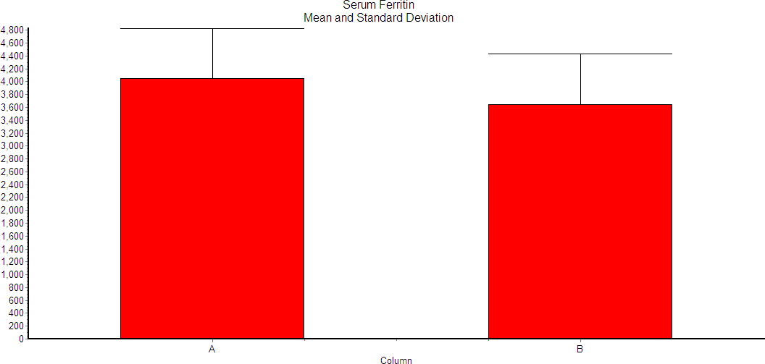

The two-tailed P value is < 0.0001, considered extremely significant. t = 20.288 with 23 degrees of freedom.

Table 2: Total Bilirubin

 | Value at the beginning of the  study | Value at the end of the study
Average | 2.59166667 | 2.64583333
Standard Deviation | 1.15642503 | 1.1560725

Graphical representation of Table 2

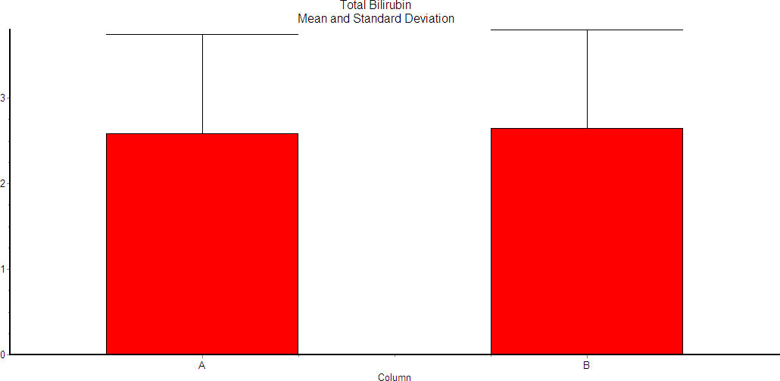

The two-tailed P value is 0.0137, considered significant.

Table 3: Direct Bilirubin

 | Value at the beginning of the  study | Value at the end of the study
Average | 0.8208333 | 0.85416667
Standard Deviation | 0.3538351 | 0.3538351

Graphical representation of Table 3

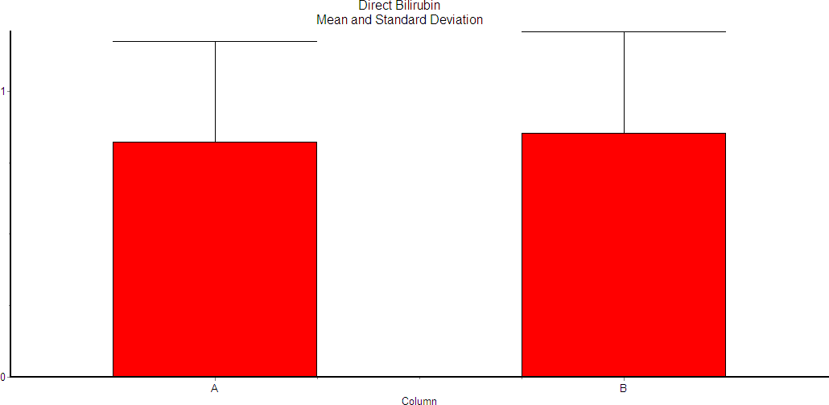

The two-tailed P value is 0.0024, considered very significant.

Table 4: Alanine Aminotransferase (ALT) / SGPT

 | Value at the beginning of the  study | Value at the end of the study
Average | 41.125 | 43.875
Standard Deviation | 32.70728213 | 31.40383873

Graphical representation of Table 4

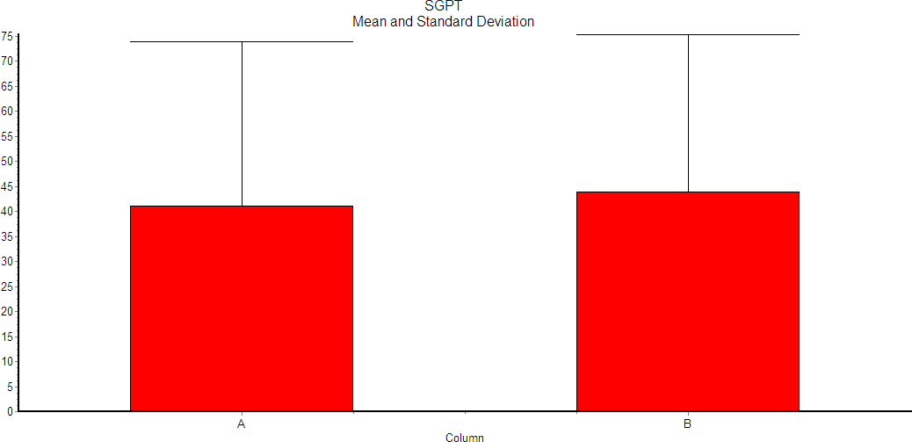
The two-tailed P value is 0.0005, considered extremely significant.

Table 5: Aspartate Aminotransferase (AST) / SGOT

 | Value at the beginning of the  study | Value at the end of the study
Average | 51.25 | 53.33333333
Standard Deviation | 39.09659165 | 36.87306861

Graphical representation of Table 5

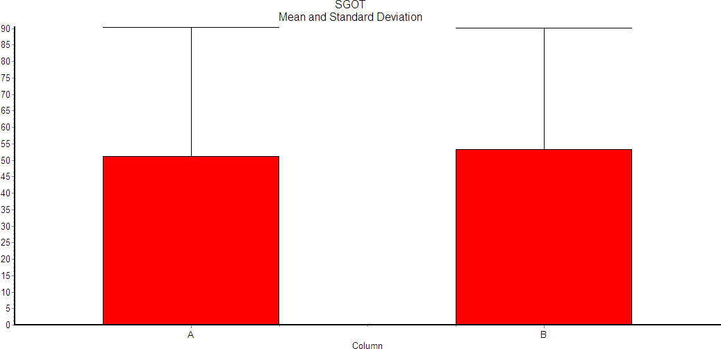
The two-tailed P value is 0.0034, considered very significant.

Table 6: Alkaline phosphatase

 | Value at the beginning of the  study | Value at the end of the study
Average | 124.7916667 | 127.5416667
Standard Deviation | 48.9844511 | 50.65739928

Graphical representation of Table 6

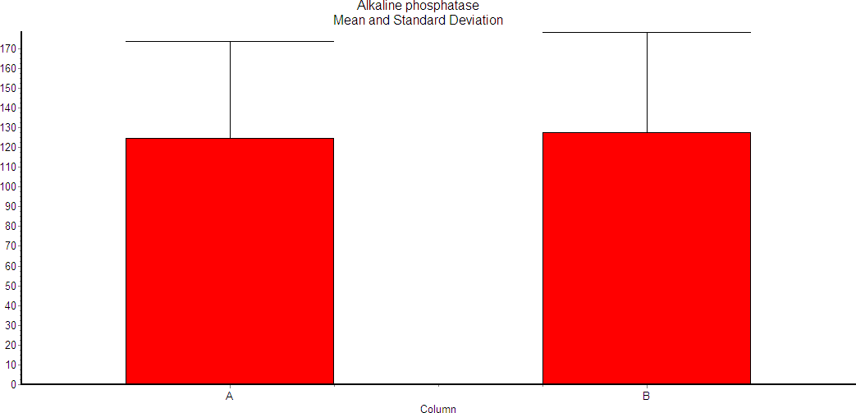

The two-tailed P value is 0.0125, considered significant. t = 2.710 with 23 degrees of freedom.

Table 7: Serum Creatinine

 | Value at the beginning of the  study | Value at the end of the study
Average | 0.475 | 0.4875
Standard Deviation | 0.129379791 | 0.129589653

Graphical representation of Table 7

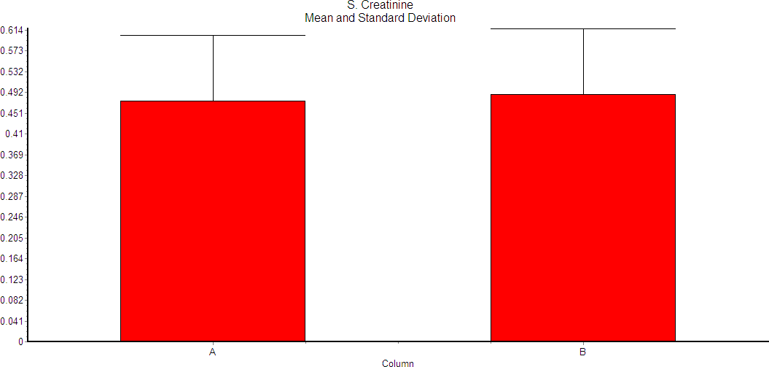

The two-tailed P value is > 0.9999, considered not significant.

Table 8: Serum Sodium

 | Value at the beginning of the  study | Value at the end of the study
Average | 135.5625 | 135.875
Standard Deviation | 3.36824203 | 3.02615411

Graphical representation of Table 8

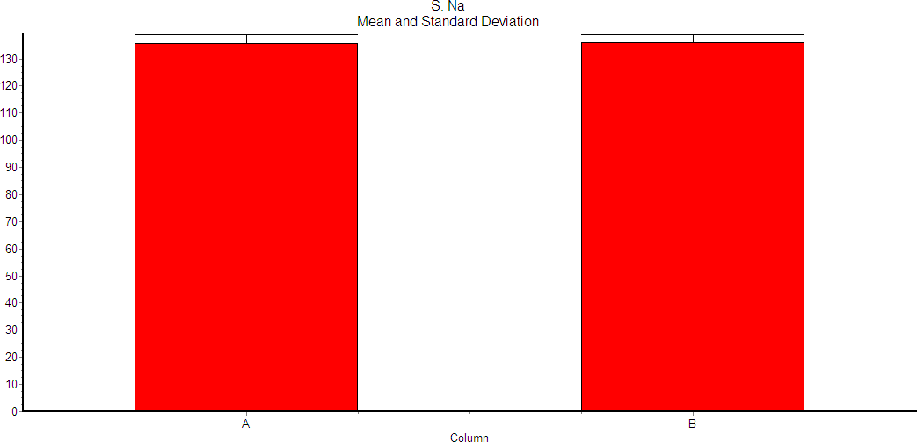

The two-tailed P value is 0.0760, considered not quite significant.

Table 9: Serum Potassium

 | Value at the beginning of the  study | Value at the end of the study
Average | 4.23333333 | 4.2541667
Standard Deviation | 0.44786126 | 0.3977974

Graphical representation of Table 9

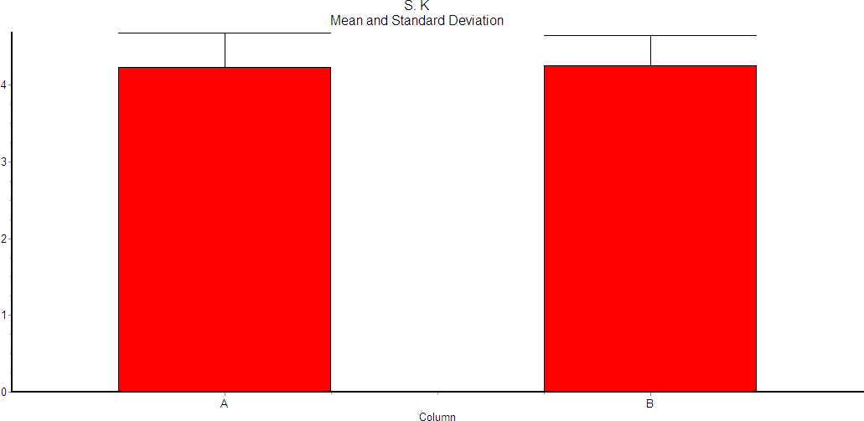

The two-tailed P value is 0.2329, considered not significant.

DISCUSSION & Results:
Thalassemia, a heterogeneous group of inherited disorders of haemoglobin synthesis, is one of the world's most common monogenic diseases. An estimated 80–90 million people in the world carry the beta thalassemia trait. The disease is also common in India with approximately 10,000– 12,000 children born every year with β thalassemia major.[1] India contributes to approximately 10% of the global disease burden.[2] Defective production of β globin chains in β thalassemia leads to an increased production of α globin chains. These globin chains get precipitated in RBCs, leading to extensive haemolysis and anaemia. Resultant hypoxia and increased erythropoietin production cause expansion of ineffective erythroid mass. Definitive treatment of thalassemia includes bone marrow transplantation and gene therapy, both of which are expensive. In resource-limited settings, repeated blood transfusions (BTs) remain the main stay of management. However, repeated BTs lead to iron overload and deposition of iron in various tissues of the body. [6] Iron overload is associated with a variety of complications affecting skeletal, cardiovascular, hepatobiliary, and endocrine systems. Hepatotoxicity due to iron overload is one of the leading causes of death in patients suffering from thalassemia.[7 10 11] To prevent these complications, iron chelation therapy is now recommended and routinely prescribed to transfusion dependent thalassemic patients.[12] Conventional iron chelators, i.e., desferioxamine and deferiprone, are effective in reducing iron overload. However, these drugs, owing to a shorter half-life, require frequent administration.
Results;
In the present study we used deferasirox as an iron chelating agent in a dose of 20 to 30mg/kg body weight, for a period of 6 months at the initiation of therapy the mean serum ferritin level was detected to be significantly higher in patients of 7–10 and 11–12 years as compared to that in patients of 1–3 years at baseline. Mean serum iron level at baseline was also significantly higher in the higher age groups as compared to the age group of 1–3years. Higher mean serum ferritin and serum iron levels in these patients could have been because of a higher number of BTs received in these patients before enrolment. With deferasirox treatment, a serial and significant decrease in mean serum ferritin and mean serum iron levels were observed in all groups (table 1) there was a decrease in serum ferritin from 4049.87ng/ml to 3647.4ng/ml this was a significant change with a p value 0f 0.0001. Furthermore, a significant negative correlation was observed between the mean dose of deferasirox prescribed and the mean serum ferritin levels. These findings suggest that deferasirox effectively reduced iron overload.

A phase III study also showed a significant decrease in serum ferritin levels (mean reduction of 1137 ± 453 ng/ml) with deferasirox treatment (30mg/kg/day) in 296 transfusion-dependent β thalassemia patients over a period of 1 year [89]. In the same study, serum ferritin levels were stabilized at 20 mg/kg/day of deferasirox [93] . Also reported a median reduction of 1048 ng/ml in serum ferritin from baseline over 1 year in transfusion dependent β thalassemia patients. In the present study, all patients received deferasirox in doses ranging from 20 to 30 mg/kg/day. While an adherence to drug administration guidelines [4] was observed in majority of the patients, concomitant use of food and improper dispersion of deferasirox was observed in 27.3% patients. This can be avoided by education of patients and caretakers regarding proper administration of deferasirox. In the present study, the mean number of BTs received was higher in age groups of more than 3 years baseline as compared to children aged 1–3 years. A significantly higher mean dose of deferasirox was prescribed to patients in higher age groups at baseline as compared to those aged 1–3 years. Furthermore, in each age group, the mean dose of deferasirox prescribed at the end of study period was significantly higher as compared to that at the baseline. The number of BT increases with age of the patient. This also increases iron overload proportionately. Hence, the requirement of a higher dose of deferasirox in these age groups was justified. An increment in dose of deferasirox was employed in patients of 1–3 years and 4–6 years to reduce iron overload and achieve target serum ferritin levels. High-serum ferritin levels require dose increment in older children; however, this was not observed in the present study. Adverse drug reactions (ADRs) were observed in nearly 95% patients. Higher incidences of ADRs in these patients can be attributed to the prolonged and continuous use of deferasirox. A positive correlation between the dose of deferasirox prescribed and the number of ADRs observed per dose was present. Taheret al. [94] have also reported a higher incidence of ADRs in patients receiving 30 mg/kg/day deferasirox as compared to those receiving a daily dose of 20 mg/kg.
Most common ADR in the present study was diarrhoea with or without blood (22.2%). Diarrhoea was reported as the most common ADR with deferasirox in phase II clinical trials [95] and reported incidence of diarrhoea in these studies was similar to that observed in the current study. Diarrhoea in these patients can be because of a faulty drug administration technique causing improper drug dispersion. In the present study, a history of nonadherence to deferasirox administration guidelines was present in more than 50% cases of diarrhoea in the form of either inadequate dispersion of deferasirox tablet or concomitant use of food. Emphasis should therefore be laid on educating the patient/caretakers at each visit to ensure better drug compliance and to reduce the incidence of adverse reactions such as diarrhea. A phase II trial has reported a higher incidence of abdominal pain (20%), raised transaminase level (20%), and tonsillitis (15%) with deferasirox. However, the incidence of these ADRs was comparatively less in the present study which may be because of the smaller sample size. Total serum bilirubin mean changed from 2.59 to 2.64 (table 2) which was also significant mean values of direct bilirubin changed from 0.82 to 0.86 (table 3) values were significant SGPT/ALT were raised from 41.1 to 43.8 (table 4) was extremely significant SGOT/AST mean value changed from 51.2 to 53 .4 (table 5) was also extremely significant. Alkaline phosphatase were raised from 124.5 to 127.5 was also significant (table 6). Raised hepatic enzyme and jaundice, observed in nearly 31% patients in the present study, were chronic (Type C) reactions. Deferasirox is metabolized through phase conjugation in the liver. This may be responsible for hepatic injury due to this drug.[96] In our study it was found that the mean change in the serum creatinine values increased from 0.475 to 0.487 (table 7) in our study this change was not significant the findings for sodium and serum potassium were not considered significant (table 8 and 9) in the study. In our study the change in serum creatinine was not significant it might be due to low sample size. The present study, which included raised serum creatinine, raised transaminase, diarrhea with or without blood, and jaundice. These ADRs recovered with supportive treatment and temporary withdrawal of the drug for a mean duration of 18 ± 8.2 days. Cappellin had also reported diarrhea, raised serum creatinine, and raised serum transaminase as the most common dose-dependent ADRs with deferasirox which require temporary withdrawal of drug. Majority (94.1%) of ADRs observed were definitely preventable. These observations suggest that deferasirox was well tolerated and relatively safe in transfusion-dependent pediatric patients of thalassemia. Majority of the ADRs were reported with higher doses of deferasirox, suggesting the need for routine monitoring of serum ferritin and maintaining the patients on lowest effective dose possible.An awareness among prescribers about ADRs of deferasirox and frequent monitoring of serum ferritin and serum iron levels as a guide to determine its dose is required to improve tolerability of this important and necessary drug.

CONCLUSION
Deferasirox is relatively well tolerated among these patients. Deferasirox is least tolerated in the dose of 30 mg/kg/day. Periodic monitoring of laboratory and clinical parameters along with suitable dose modification can help optimize the drug therapy and improve the safety of this drug. Caution should be exercised for the right method of drug administration to improve efficacy and minimize ADRs due to deferasirox. Majority of the ADRs were reported with higher doses of deferasirox, suggesting the need for routine monitoring of serum ferritin and maintaining the patients on lowest effective dose possible. An awareness among prescribers about ADRs of deferasirox and frequent monitoring of serum ferritin and serum iron levels as a guide to determine its dose is required to improve tolerability of this important and necessary drug. Further multi-centered studies with more sample size are needed.

SUMMARY
β-Thalassemia Major is a serious disease occurring at a tender age and it requires extensive research on its treatment, which is the transfusion of blood and the resulting haemosiderosis. The present study was carried out in a tertiary care hospital located in a rural area for a period of six months to aid understanding the efficacy, safety and timely prevention of any adverse drug reactions which come with the administration of Deferasirox. With deferasirox treatment, a serial and significant decrease in mean serum ferritin and mean serum iron levels were observed in all groups, there was a decrease in serum ferritin from 4049.87ng/ml to 3647.4ng/ml this was a significant change with a p value 0f 0.0001.

LIMITATIONS OF THE STUDY
Reduced sample size of 24 patients is a limiting factor for applying the conclusions of this study to a larger population.Deferasirox is a relatively now oral iron chelator & larger sample size is required to establish safety/efficacy profile of this wonder drug.The study will be continued to achieve a higher sample size and the observations will be inferred with the inclusion of other related variables.

REFERENCES

1. Mohanty D, Colah RB, Gorakshakar AC, et al. Prevalence of beta-thalassemia and other haemoglobinopathies in six cities in India: a multicentre study. J Community Genet. 2013;4:33– 42.

2. Mariani R, Trombini P, Pozzi M, et al. Iron metabolism in thalassemia and sickle cell disease. Mediterr J Hematol Infect Dis. 2009;1:006–006.

3. Fung EB, Harmatz P, Milet M, et al. Morbidity and mortality in chronically transfused subjects with thalassemia and sickle cell disease: A report from the multi-center study of iron overload. Am J Hematol.2007;82:255–65.

4. Riaz H, Riaz T, Khan MU, et al. Serum ferritin levels, socio-demographic factors and desferrioxamine therapy in multi-transfused thalassemia major patients at a government tertiary care hospital of Karachi, Pakistan. BMC research notes. 2011;4:287–287.

5. Taksande A, Prabhu S, Venkatesh S. Cardiovascular Aspect of Beta-Thalassaemia. CardiovascHematol Agents Med Chem. 2012;10:25–30.

6. NC Joshi, Common clinical cases (part II), Case 1: Beta Thalassemia, Clinical Pediatrics, Second edition, 2012, page 259-281.

7.Iancu TC, Neustein HB, Landing BH. The liver in thalassemia major: ultra structural observations. in Iron Metabolism, Ciba Foundation Symposium 51 Elsevier ExcerptaMedica North Holland publishers 1977; 1(1): 293-316.

8. Jean G, Terzoli S, Mauri R, et al. Cirrhosis associated with multiple transfusions in thalassaemia. Arch. Dis. Child. 1984; 59(1): 67-70.

9. Borgna-Pignatti C, Rugolotto S, De Stefano P, et al. Survival and disease complications in thalassemia major. Ann NY Acad Sci. 1998; 850(1): 227-31.

10. Olivieri NF, Brittenham GM. Iron-chelating therapy and the treatment of thalassemia. Blood. 1997; 89(3): 739-61.

11. Olivieri NF. The ß-thalassemias. N Engl J Med. 1999; 341(2): 99-109.

12.Porter JB. Practical management of iron overload.Br J Haematol. 2001; 115(2): 239-52.

13. National Institutes of Health. Management and therapy of sickle cell disease.National Heart, Lung, and Blood Institute.4thedition.NIH Publication. 2002; 333(4): 96-17.

14. McLaren GD, Muir WA, Kellermeyer RW. Iron overloads disorders: natural history, pathogenesis, diagnosis, and therapy. Crit Rev Clin Lab Sci. 1983; 19(3): 205-66.

15. Prati D, Maggioni M, Milani S, et al. Clinical and histological characterization of liver disease in patients with transfusion-dependent beta-thalassemia. A multicenter study of 117 cases.Haematologica. 2004; 89(10): 1179-86.

16. Engle MA, Erlandson M, Smith CH. Late cardiac complications of chronic severe refractory anaemia with hemochromatosis. Circulation 1964; 30(5): 698- 705.

17. Schrier SL, Angelucci E. New strategies in the treatment of thalassemias.Annu Rev Med. 2005; 56(1): 157-71.

18. Cappellini MD, Zanaboni L. Efficacy and Safety of Deferasirox. Transfusion Iron Chelation Therapy, US Hematology. Touch Briefing 2009; 107(9): 68-73.

19. Cappellini MD, Bejaoui M, Agaoglu L, et al. Prospective evaluation of patient-reported outcomes during treatment with Deferasirox or deferoxamine for iron overload in patients with beta-thalassemia. ClinTher. 2007; 29(5): 909–17.

20. Vichinsky E, Onyekwere O, Porter J, et al. A randomized comparison of Deferasirox versus deferoxamine for the treatment of transfusional iron overload in sickle cell disease. Br J Haematol. 2007; 136(3): 501–8.

21. Cappellini MD, Giardina P, Porter J, et al. Long-term safety and tolerability of the oncedaily, oral iron chelator Deferasirox (Exjade1, ICL670) in patients with transfusional iron overload. Blood 2006; 108(1): 501a.

22. Cooley, T.B.; Witwer, E. R. & Lee, P. (1927). Anemia in children: With splenomegaly andpeculiar changes in the bones report of cases. Am J Dis Child, 34, p.p. 347 - 363.

23. Cooley, TB. (1946), M.D. 1871-1945. Am J Dis Child, 71, p.p. 77 - 79.

24. Weatherall, D.J. & Clegg, J.B. (2001).The β and δβ thalassemia association with structural hemoglobin variants. In: Weatherall DJ, Clegg JB. Eds. The Thalassemia syndromes.4th ed. Oxford, UK: Blackwell scientific Publications, p.p.393-449.

25. Weatherall, D.J. (1997). Fortnightly review: The thalassaemias BMJ, 314, p. 1675.

26. Chernoff, AI. (1959). The Distribution of the Thalassemia Gene: A Historical Review. Blood,14, p.p. 899 - 912.

27. Hillman, R.S. & Ault, K.A. (1995).Hematology in Practical Practice, a Guide to Diagnosis and Management, McGraw-Hill, New York

28. Fosburg, M.T. & Nathan, D.G. (1990).Treatment of Cooley's anemia.Blood, 76, p.p. 435 - 444.

29. Borgna-Pignatti, C. &Galanello, R. (2004).Thalassemias and related disorders: quantitative disorders of hemoglobin synthesis. In Wintrobe's Clinical Hematology Volume 42.11thedition.Lippincott Williams & Wilkins. Philadelphia, p.p. 1319-1365.

30. Olivieri, N.F. &Brittenham, G.M. (1997).Iron-chelating therapy and the treatment of thalassemia.Blood, 89, p.p. 739-761.

31. Brittenham, G.M., Cohen, A.R., McLaren, C.E., Martin, M.B., Griffith, P.M., et al. (1993). Hepatic iron stores and plasma ferritin concentration in patients with sickle cell anemia and thalassemia major. Am J Hematol, 42(1), p.p. 81-85.

32. Risdon, R.A., Flynn, D.M. & Barry, M. (1973). The relation between liver iron concentration and liver damage in transfusional iron overload in thalassaemia and the effect ofchelation therapy.Gut, 14, p. 421.

33. Hershko C, Weatherall DJ. (1988). Iron-chelating therapy.Crit Rev Clin Lab Sci, 26, p.p.303- 345.

34. Hershko, C, Konijn, A.M. & Link, G. (1998). Iron chelators for thalassaemia. Br J Haematol,101, p.p.399-406.

35. Zurlo, M.G., De Stefano, P., Borgna-Pignatti, C., Di Palma, A., Piga, A., et al. (1989).Survivaland causes of death in thalassaemia major.Lancet, 2(8653), p.p. 27-30.

36. Fosburg, M.T. & Nathan, D.G. (1990).Treatment of Cooley's anemia.Blood, 76, p.p. 435 - 444.

37. Stohs, S.J. &Bagchi, D. (1995).Oxidative mechanisms in the toxicity of metal ions. FreeRadicBiol Med, 18(2), p.p. 321-336.

38. Eaton, J.W. & Qian, M. (2002). Molecular bases of cellular iron toxicity. Free RadicBiol Med,32(9), p.p. 833-840.

39. Kadiiska, M.B., Burkitt, M.J., Xiang, Q.H., & Mason, R.P. (1995). Iron supplementation generates hydroxyl radical in vivo. An ESR spin-trapping investigation.JClinInvest, 96(3), p.p. 1653-1657.

40. Schaible, U.E. & Kaufmann, S.H. (2004).Iron and microbial infection.Nat Rev Microbiol,2(12), p.p. 946-53.

41. Aslan, M. & Freeman, B.A. (2004).Oxidant-mediated impairment of nitric oxide signaling in sickle cell disease-mechanisms and consequences.CellMolBiol, 50(1), p.p. 95-105.

42. Hebbel, R.P., Eaton, J.W., Balasingam, M., & Steinberg, M.H. (1982).Spontaneous oxygenradical generation by sickle erythrocytes.JClin Invest, 70(6), p.p. 1253-1259.

43. Chakraborty, D. & Bhattacharyya, M. (2001).Antioxidant defense status of red blood cells of patients with beta-thalassemia and Ebeta-thalassemia.ClinChimActa, 305(1-2), p.p.123-129.

44. Wood, K.C., Hsu, L.L. & Gladwin, M.T. (2008). Sickle cell disease vasculopathy: a state of nitric oxide resistance. Free RadicBiol Med, 44(8), p.p. 1506-1528.

45. Neidlinger, N.A., Larkin, S.K., Bhagat, A., Victorino, G.P. &Kuypers, FA.(2006). Hydrolysisof Phosphatidylserine-exposing Red Blood Cells by Secretory Phospholipase A2 Generates Lysophosphatidic Acid and Results in Vascular Dysfunction. J. Biol.Chem., 281, p.p. 775 – 781.

46. Reid, M., Badaloo, A., Forrester, T. &Jahoor, F. (2006).In vivo rates of erythrocyte glutathione synthesis in adults with sickle cell disease.Am J PhysiolEndocrinolMetab, 291, p.p. E73 - E79.

47. Bacon, B.R., Tavill, A.S., Brittenham, G.M., Park, C.H., &Recknagel, R.O. (1983).Hepaticlipid peroxidation in vivo in rats with chronic iron overload.JClin Invest, 71(3), p.p.429-439.

48. Britton, R.S.; Bacon, B.R. &Recknagel, R.O. (1987). Lipid peroxidation and associated hepaticorganelle dysfunction in iron overload. Chem Phys Lipids, 45(2-4), p.p. 207-239.

49. Cunningham, M.J., Macklin, EA., Neufeld, E.J., Cohen, A.R., & the Thalassemia Clinical Research Network. (2004). Complications of β-thalassemia major in North America.Blood, 104, p.p. 34 - 39.

50. Borgna-Pignatti, C., Rugolotto, S., De Stefano, P., Zhao, H., Cappellini, M.D., et al. (2004). Survival and complications in patients with thalassemia major treated with transfusion and deferoxamine. Haematologica, 89, p.p. 1187 - 1193.

51. Brittenham, G.M., Cohen, A.R., McLaren, C.E., Martin, M.B., Griffith, P.M., et al. (1993).Hepatic iron stores and plasma ferritin concentration in patients with sickle cell anemia and thalassemia major.Am J Hematol, 42(1), p.p. 81-85.

52. Angelucci, E., Brittenham, G.M., McLaren, C.E., Ripalti, M., Baronciani, D., et al. (2000).Hepatic iron concentration and total body iron stores in thalassemia major. N EnglJMed, 343(5), p.p. 327-331.

53. Villeneuve, J.P., Bilodeau, M., Lepage, R., Cote, J. & Lefebvre, M. (1996).Variability inhepatic iron concentration measurement from needle-biopsy specimens. J Hepatol,25(2): 172- 177.

54. Wood, J.C., Tyszka, J.M., Carson, S., Nelson, M.D. & Coates, T.D. (2004).Myocardial ironloading in transfusion-dependent thalassemia and sickle cell disease.Blood, 103,p.p. 1934 - 1936.

55. Tanner, M.A., He, T., Westwood, M.A., Firmin, D.N., Pennell, D.J. & Thalassemia International Federation Heart T2* Investigators. (2006). Multi-center validation of the transferability of the magnetic resonance T2* technique for the quantification of tissue iron. Haematologica, 91, p.p. 1388 – 1391.

56. Fosburg, M.T. & Nathan, D.G. (1990).Treatment of Cooley's anemia.Blood, 76, p.p. 435 - 444.

57. Nathan, D.G. &Piomelli, S. (1990). Oral iron chelators.SeminHematol, 27(2), p.p. 83-5.

58. Borgna-Pignatti, C. &Galanello, R. (2004).Thalassemias and related disorders: quantitative disorders of hemoglobin synthesis. In Wintrobe's Clinical Hematology Volume 42.11thedition.Lippincott Williams & Wilkins. Philadelphia, p.p. 1319-1365.

59. Anderson, L.J., Westwood, M.A., Holden, S., Davis, B., Prescott, E.,et al. (2004). Myocardialiron clearance during reversal of siderotic cardiomyopathy with intravenous desferrioxamine: a prospective study using T2* cardiovascular magnetic resonance.Br J Haematol, 127(3), p.p. 348-355.
60. Olivieri, N.F. & Brittenham, G.M. (1997). Iron-chelating therapy and the treatment of thalassemia.Blood, 89, p.p. 739-761.

61. Pippard, M.J., Callender, S.T., Warner, G.T. &Weatherall, D.J. (1979). Iron absorption andloading in beta-thalassaemia intermedia. Lancet, 2, p.p. 819-821.

62. Pootrakul, P., Kitcharoen, K., Yansukon, P., et al. (1988). The effect of erythroid hyperplasiaon iron balance.Blood,71, p.p.1124-1129.

63. Risdon, R.A., Flynn, D.M. & Barry, M. (1973). The relation between liver iron concentration and liver damage in transfusional iron overload in thalassaemia and the effect of chelation therapy. Gut, 14, p421.

64. Hershko C, Weatherall DJ. (1988). Iron-chelating therapy.Crit Rev Clin Lab Sci, 26, p.p.303- 345.

65. Hershko, C, Konijn, A.M. & Link, G. (1998). Iron chelators for thalassaemia. Br J Haematol,101, p.p.399-406.

66. Iancu, T.C, Neustein, H.B. & Landing, B.H. (1977).The liver in thalassaemia major:ultrastructural observations. In: Iron metabolism: Ciba Symposium 51. Amsterdam:Elsevier, p.p. 293-309.

67. Thakerngpol, K., Fucharoen, S., Boonyaphipat, P., et al. (1996). Liver injury due to iron overload in thalassemia: histopathologic and ultrastructural studies. Biometals, 9,p.p. 177-183.

68. Risdon, R.A., Flynn, D.M. & Barry, M. (1973). The relation between liver iron concentration and liver damage in transfusional iron overload in thalassaemia and the effect of chelation therapy. Gut, 14, p. 421.

69. Witzleben, C.L. & Wyatt, J.P. (1961).The effect of long survival on the pathology of thalassaemia major.JPatholBacteriol, 82, p.p.1-12.

70. Jean, G., Terzoli, S., Mauri, R., et al. (1984). Cirrhosis associated with multiple transfusions in thalassaemia. Arch Dis Child, 59, p.p. 67-70.

71. Italian Working Group on Endocrine Complications in Non-endocrine Diseases. (1995). Multicentre study on prevalence of endocrine complications in thalassaemia major. ClinEndocrinol (Oxf ), 42, p.p.581-586.

72. Karydis, I., Karagiorga-Lagana, M., Nounopoulos, C., &Tolis, G. (2004). Basal and stimulated levels of growth hormone, insulin-like growth factor-I (IGF-I), IGF-Ibinding and IGF-binding proteins in beta-thalassemia major. J PediatrEndocrinolMetab, 17(1), p.p. 17-25.

73. Wu, K.H., Tsai, F.J. & Peng, C.T. (2003).Growth hormone (GH) deficiency in patients with beta-thalassemia major and the efficacy of recombinant GH treatment.AnnHematol, 82(10), p.p. 637-640.

74. Italian Working Group on Endocrine Complications in Non-endocrine Diseases. (1995). Multicentre study on prevalence of endocrine complications in thalassaemia major. ClinEndocrinol (Oxf ), 42, p.p.581-586.

75. Cavallo-Perin, P., Pacini, G., Cerutti, F., et al. (1995).Insulin resistance and hyperinsulinemia in homozygous β-thalassemia.Metabolism, 44, p.p. 281-286.

76. Gullo, L., Corcioni, E., Brancati, C., Bria, M., Pezzilli, R., et al. (1993).Morphologic and functional evaluation of the exocrine pancreas in β-thalassemia major.Pancreas, 8,p.p.176-80.

77. Magro, S., Puzzonia, P., Consarino C., et al. (1990).Hypothyroidism in patients with thalassemia syndromes.ActaHaematol, 84, p.p.72-76.

78. Sklar, C.A., Lew, L.Q., Yoon, D.J., David, R. (1987). Adrenal function in thalassemia majorfollowing long-term treatment with multiple transfusions and chelation therapy: evidence for dissociation of cortisol and adrenal androgen secretion. Am J Dis Child,141, p.p. 327-330.

79. Du, Z.D., Roguin, N., Milgram, E., Saab, K., &Koren, A. (1997).Pulmonary hypertension inpatients with thalassemia major.Am Heart J, 134, p.p.532-537.

80. Factor, J.M., Pottipati, S.R., Rappaport, I., Rosner, I.K., Lesser M.L., et al. (1994). Pulmonary function abnormalities in thalassemia major and the role of iron overload. Am JRespirCrit Care Med, 149, p.p.1570-1574.

81. Tai, D.Y.H., Wang, Y.T., Lou, J., Wang, W.Y., MakKH., et al. (1996). Lungs in thalassaemia major patients receiving regular transfusion.EurRespir J, 9, p.p. 1389-1394.

82. Pootrakul, P., Kitcharoen, K., Yansukon, P., et al. (1988). The effect of erythroid hyperplasiaon iron balance.Blood,71, p.p.1124-1129.

83. Anapliotou, M.L.G., Kastanias, I.T., Psara, P., Evangelou, E.A., Liparaki, M., et al. (1995). Thecontribution of hypogonadism to the development of osteoporosis in thalassaemia major: new therapeutic approaches. ClinEndocrinol (Oxf ), 42, p.p. 279-287.

84. Gabutti V, Piga A. Results of long-term iron-chelating therapy. ActaHaematol. 1996;95:26– 36.

85. Modell B, Khan M, Darlison M. Survival in β-thalassaemia major in the UK: data from the UK Thalassaemia Register. Lancet. 2000;355:2051–2

86. Olivieri NF, Brittenham GM. Iron-chelating therapy and the treatment of thalassemia. Blood. 1997;89:739–61.

87. Piga A, Galanello R, Forni GL, et al. Randomized phase II trial of deferasirox (Exjade, ICL670), a once-daily, orally-administered iron chelator, in comparison to deferoxamine in thalassemia patients with transfusional iron overload. Haematologica. 2006;91:873–80.

88. Galanello R, Piga A, Forni GL, et al. Phase II clinical evaluation of deferasirox, a once-daily oral chelating agent, in paediatric patients with β-thalassaemia major. Haematologica. 2006;91:1343–51.

89. Cappellini MD, Cohen A, Piga A, et al. A phase 3 study of deferasirox (ICL670), a oncedaily oral iron chelator, in patients with beta-thalassemia.Blood. 2006;107:3455–62.

90. Vichinsky E, Fischer R, Fung E, et al. A randomized, controlled phase II trial in sickle cell diseasepatients with chronic iron overload demonstrates that the once-daily oral iron chelator deferasirox (Exjade®, ICL670) is well tolerated and reduces iron burden. Blood. 2006;106abst.

91. Porter J, Vichinsky E, Rose C, Piga A, Olivieri N, Gattermann N, Maertens J, Rabault B, GathmannI, Alberti D. A phase II study with ICL670 (Exjade®), a once-daily oral iron chelator, in patients with various transfusion-dependent anemias and iron overload. Blood. 2004;104abst.

92. Piperno A. Classification and diagnosis of iron overload. Haematologica. 1998;83:447–55.

93. Pennell DJ, Porter JB, Cappellini MD, El-Beshlawy A, Chan LL, Aydinok Y, et al. Efficacy of deferasirox in reducing and preventing cardiac iron overload in beta-thalassemia. Blood.2010;115:2364–71.

94. Taher A, El-Beshlawy A, Elalfy MS, Al Zir K, Daar S, Habr D, et al. Efficacy and safety of deferasirox, an oral iron chelator, in heavily iron-overloaded patients with beta-thalassaemia: The ESCALATOR study. Eur J Haematol. 2009;82:458–65.

95. Piga A, Galanello R, Forni GL, Cappellini MD, Origa R, Zappu A, et al. Randomized phase II trial of deferasirox (Exjade, ICL670), a once-daily, orally-administered iron chelator, in comparison to deferoxamine in thalassemia patients with transfusional iron overload. Haematologica. 2006;91:873–80.

96. Wood JC, Kang BP, Thompson A, Giardina P, Harmatz P, Glynos T, et al. The effect of deferasirox on cardiac iron in thalassemia major: Impact of total body iron stores. Blood. 2010;116:537–43.

